**Exp No**1: **Name:** PONNURI ANIRUDDHA

**Date:**16/08/2022 **Reg No:** RA2112704010015

Operating system Installation, Basic Linux commands

**Aim:**

Installation of OS and Practice of basic Unix Shell Commands

**Procedure:** INSTALLATION OF:

1. VMware Player

To download VMware Player:

* Navigate to the VMware Download Center.
* Locate VMware Player under Desktop & End user Computing.
* Select the installer from the list according to our host operating system.
* Click Download.
* If prompted, log in to our Customer Connect profile. If we do not have a profile, create one. For more information, see How to create a Customer Connect profile (2007005)
* Ensure that our profile is complete and enter all mandatory fields.
* Review the End User License Agreement and click Yes if we agree.

If the installer fails to download during the download process:

* Delete the cache in our web browser.
* Disable the pop-up blocker in our web browser.
* Microsoft Internet Explorer: How to turn Internet Explorer Pop-up Blocker on or off on a Windows XP SP2-based computer
* Try to download using a different web browser application.
* Disable any local firewall software.
* Restart our machine.
* Download the installer from a different computer or network.

To install VMware Player on a

1. Windows Host:

* Log in to the Windows host.
* Open the folder where the VMware Player installer was downloaded. The default location is the Downloads folder for the user account on the Windows host.
* Right-click the installer and click Run as Administrator.
* Follow the on-screen instructions to finish the installation.
* Restart the host machine.

After Installation:

* The installer creates a desktop shortcut, a quick launch shortcut, or a combination of these options in addition to a Start Menu item.
* To start VMware Player on a Windows host system, select Start > Programs > VMware Player.

1. Linus Host:

* Log in to the Linux host with the user account information that is to be used in the VMware software.
* Open the terminal Interface.
* Change to root.
* Change the directories to the directory that contains the VMware Player bundle installer file. The default location is the download directory for the user.
* Run the appropriate player installer file for the host system.

There are a few command line operations available:

* --gtk

Opens the GUI-based VMware installer, which is the default option.

* --console

Use the terminal for installation.

* --custom
* Use this option to customize the locations of the installation directories and set the hard limit for the number of open file descriptors.
* --regular

Shows installation questions that have not been answered before or are required. This is the default option.

* --ignore-errors or -I
* Allows the installation to continue even if there is an error in one of the installer scripts. Because the section that has an error does not complete, the component might not be properly configured.
* --required

Shows the license agreement only and then proceeds to install Player.

* Accept the license agreement.
* Follow the on-screen instructions or prompts to finish the installation.
* Restart the Linux host.

After Installation

* VMware Player can be started from the command line on all Linux distributions.
* On some Linux distributions, VMware Player can be started in the GUI from the System Tools menu under Applications.
* To start VMware Player on a Linux host system from the command line, run the vmplayer command in a terminal window

2.WINDOWS

Step 1 - Format the drive and set the primary partition as active

1. Connect the USB flash drive to our other PC.
2. Open Disk Management: Right-click on Start and choose Disk Management.
3. Format the partition: Right-click the USB drive partition and choose Format. Select the FAT32 file system to be able to boot either BIOS-based or UEFI-based PCs.
4. Set the partition as active: Right-click the USB drive partition and click Mark Partition as Active.

Step 2 - Copy Windows Setup to the USB flash drive

1. Use File Explorer to copy and paste the entire contents of the Windows product DVD or ISO to the USB flash drive.
2. Optional: add an unattended file to automate the installation process. For more information, see Automate Windows Setup.

Step 3 - Install Windows to the new PC

1. Connect the USB flash drive to a new PC.
2. Turn on the PC and press the key that opens the boot-device selection menu for the computer, such as the Esc/F10/F12 keys. Select the option that boots the PC from the USB flash drive.

Windows Setup starts. Follow the instructions to install Windows.

1. Remove the USB flash drive.

3.Linux

* Download .iso or the ISO files on a computer from the internet and store it in the CD-ROM or USB stick after making it bootable.
* We need to restart our computer after attaching pen drive into the computer. Press enter at the time of boot, here select the pen drive option to start the further boot process. Try for a manual boot setting by holding F12 key to start the boot process. This will allow we to select from various boot options before starting the system.
* Set the keyboard lawet.
* Now we will be asked What apps would we like to install to start with Linux? The two options are ‘Normal installation’ and ‘Minimal installation’.
* Select the drive for installation of OS to be completed. Select “Erase Disk and install Ubuntu” in case we want to replace the existing OS otherwise select “Something else” option and click INSTALL NOW
* A small panel will ask for confirmation. Click Continue in case we don’t want to change any information provided. Select our location on the map and install Linux.
* Provide the login details.
* After the installation is complete we will see a prompt to restart the computer

3.Dual OS

Dual operating systems can be downloaded in many different ways. Some of those

ways are as follows :

* Use linux in windows as a virtual machine : This runs a Linux OS like any other

application within Windows. This is also one of the safest ways to get a feel of Linux.

* However, this will utilize our system resources and if we have less than 4Gb of

RAM, I won’t advise using it extensively.

* Use a live version of Linux: In this method, we put Linux on a USB or DVD and we

boot from it. This is usually slow and our changes done to the Linux system are

(normally) not saved. This is particularly useful if we just want to see what Linux

feels like.

* Remove Windows and Linux: If we have backed up our data and have a recovery or

installation disk of Windows ready with we or if we are determined that we are not

going back to Windows, we can remove Windows completely and use only Linux.

* Install Linux alongside Windows: This method is called dual booting Linux with

Windows. Here, we install Linux on a system that already has Windows. And when

our system powers up, we can choose if we want to use Windows or Linux. This

involves touching the disk partition and sometimes boot order. Absolute beginners

often find it complicated but this is the best way to use Linux and Windows together

in one system. And in this article, we’ll see how to dual boot Linux Mint with

Windows 10.

The steps that are to be followed for downloading linux as the second operating

system are as follows:

1. Create a live USB or disk:

A live USB is a portable USB-attached external data storage device containing

a full operating system that can be booted from. The term is reminiscent of

USB flash drives but may encompass an external hard disk drive or solid-state

drive, though they may be referred to as "live HDD" and "live SSD"

respectively.

2.Make a new partition for the Linux meet:

In the windows system go to the start menu and click partition then a disk management utility is shown. Open the Disk Management System. In this disk

management system carefully select the disk from which we should shrink

the volume to create the required space for our required partition.

3. Boot in to live USB:

Plug the live USB or disk into the computer and restart the computer. While

booting the computer press F10 or F12 function key (defers from computer to

computer) to go to the boot menu. Now, choose the option to boot from USB or

Removable Media.

4. Start the installation:

This step might take some time for completion. The first thing asked is the

language in which this will operate. Then it does a few checks on the available

space, battery and internet connection.

5. Prepare the partition:

The most important aspect in downloading the dual os is where the files are to

be stored. The application gives a few options on where to store the files. The

options given are as follows:

The last option should be selected.

6. Create root, swap and home:

Create a root partition. Choose the available free space and then press +

The next part is to create a swap partition. The next query is regarding the swap size that should be put. This depends on the available RAM size, the user needs, available disk space and whether the user uses hibernation or not. The suggested swap size for RAM available is as follows:

RAM less than 2 GB: Swap should be double the size of RAM

RAM between 2 to 4 GB: Swap should be RAM size + 2 GB

RAM between 6 GB to 8 GB: Swap should be size of RAM

RAM more than 8 GB: Swap should be half the size of RAM or less

The next step is to create Home. Try to allocate the maximum space available for home because this is where the files will be stored and saved.

7.Then click on the install now button.

8.Complete the rest of the process.

9.After completing the rest of the process restart the system

10.Dual Operating systems have been installed in the systems and can be used at any required time.

4. Linux in VMware:

. There are a few prerequisites that need to be followed to install Ubuntu on VMware. The

requirements to do so are as follows:

1. A host system with minimum conditions of:

1. 8GB of memory

2. A Quad core CPU

3. 500 GB of hard disk space

2. VMware Workstation Pro or Player Application:

3. Ubuntu Operating system to install on VMware Workstation

The steps to download linux in VMware is as follows:

1. Fire up VMWare Workstation

Download the VMWare Workstation application for our host operating system and install it on our machine. The installation procedure is pretty simple and straight. Read the documentation for more details. Open the app after installation. Create a new Virtual Machine.  
  
  
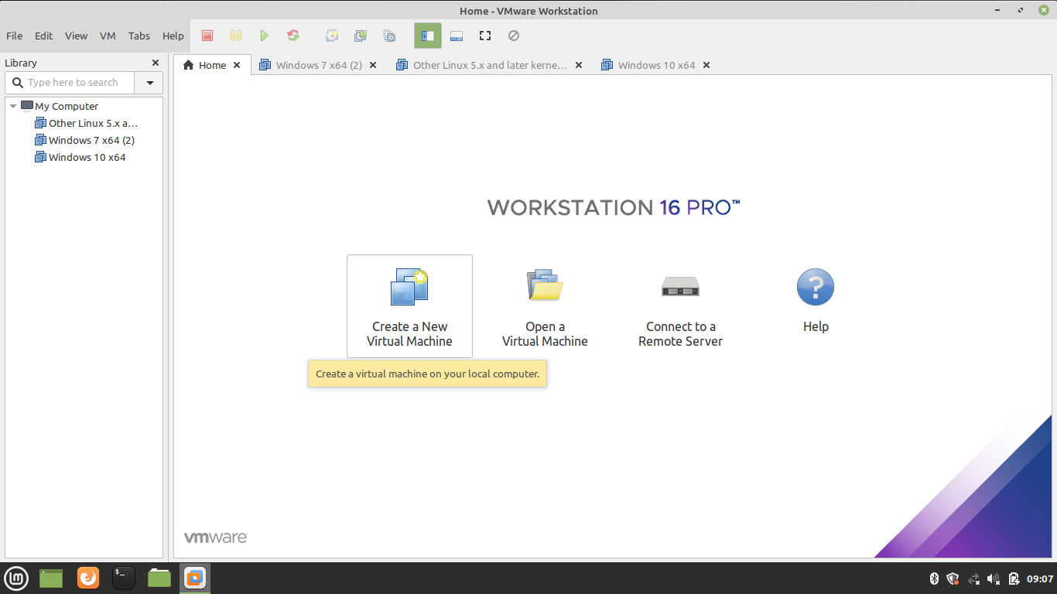

1. Select Custom Configuration Wizard

We can choose either Typical or Custom Wizard. We recommend selecting Custom if we want to install with all the configurations. If we are okay with default configurations then go ahead with Typical configurations.  
  
  
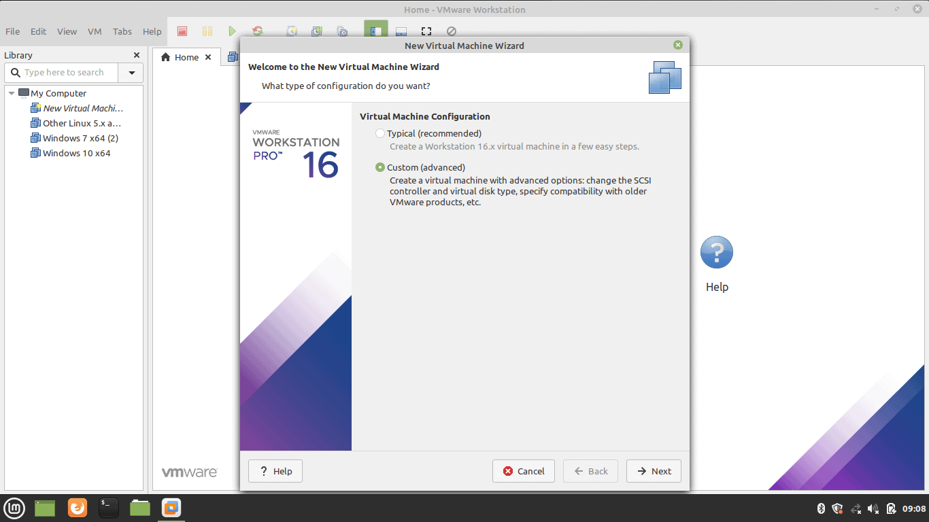

1. Select Virtual Machine Hardware Compatibility

Go with the default option if we don’t have the choice.  
  
  
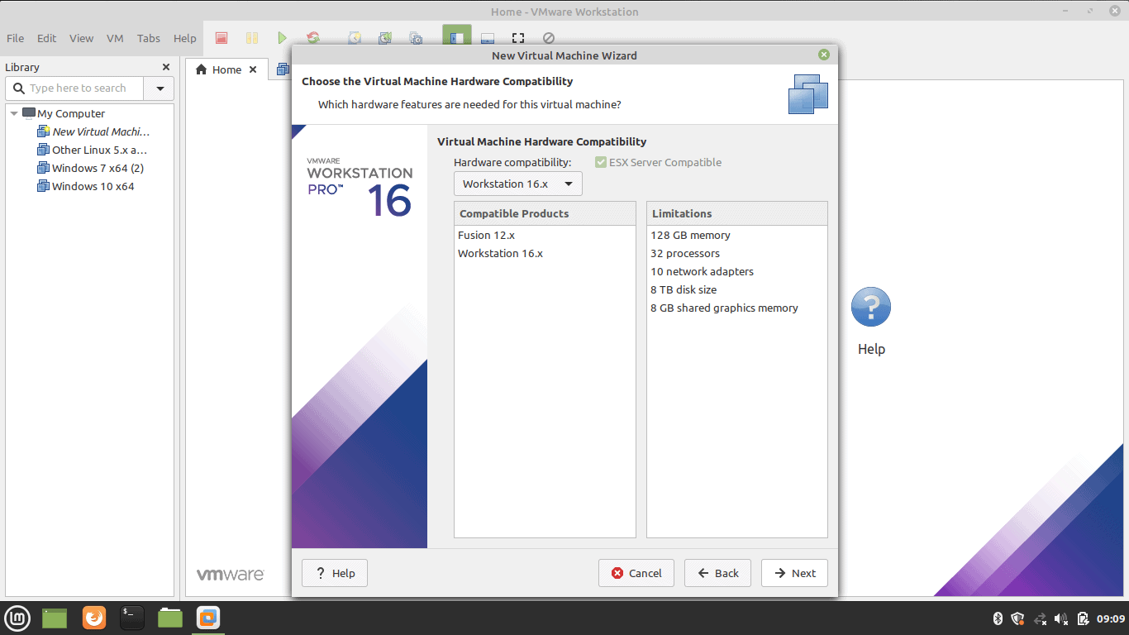

1. Select the Operating System Media

Select ‘I will install the operating system later’ for an interactive installation.  
  
  
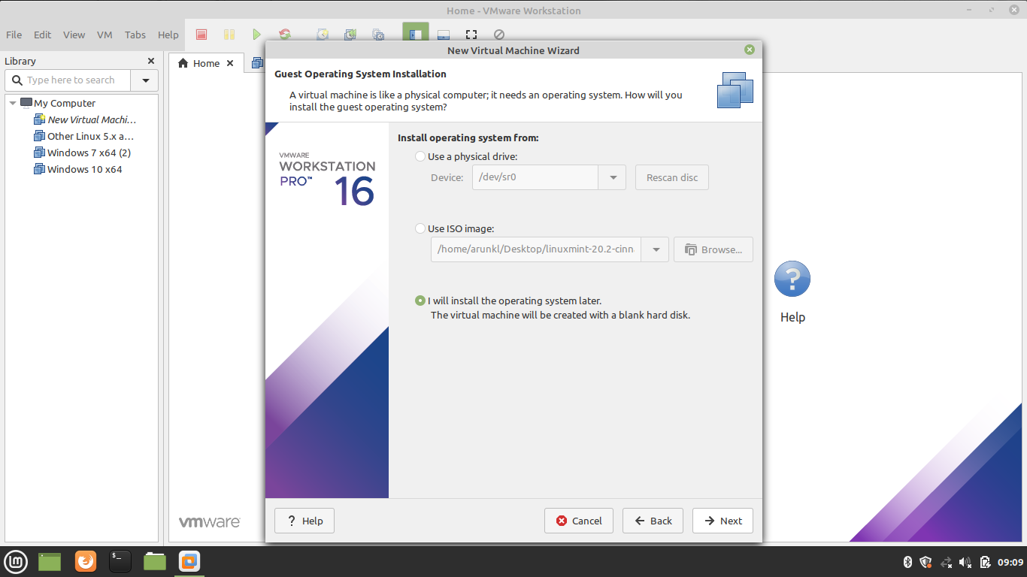

1. Select Guest Operating System

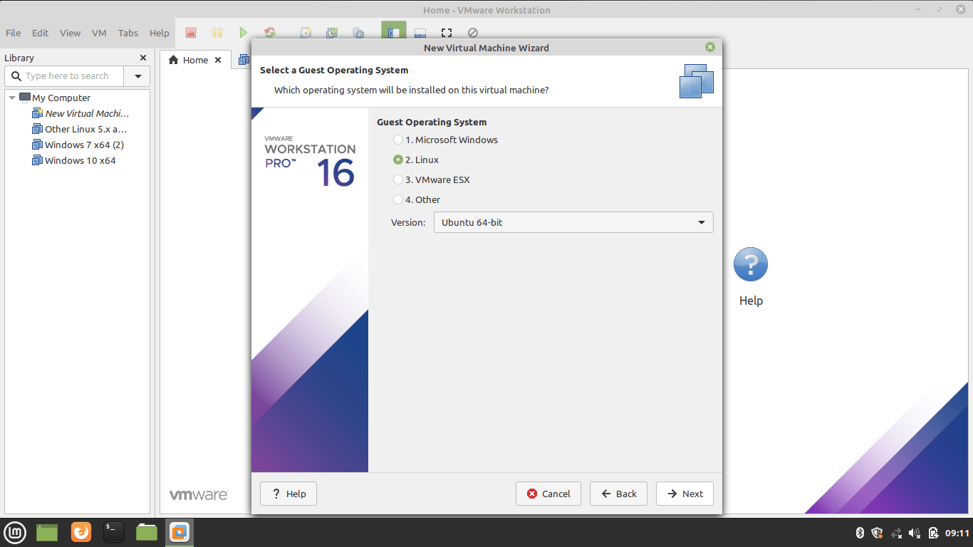

1. Name the Virtual Machine Name and location

Type a name and give the location details.  
  
  
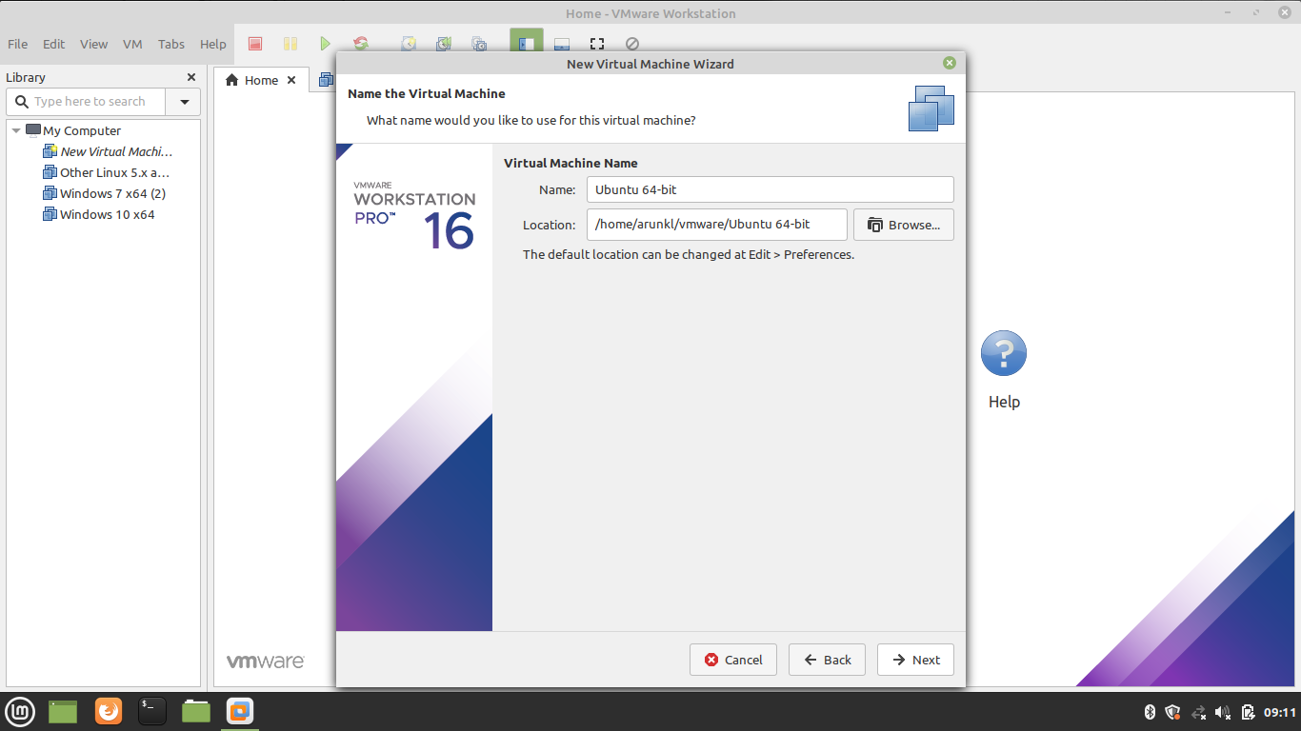

1. Allocate the Processors

Assign the processors, Calculate the processor required to run the host machine. Assign the leftover resources to the virtual machine.  
  
  
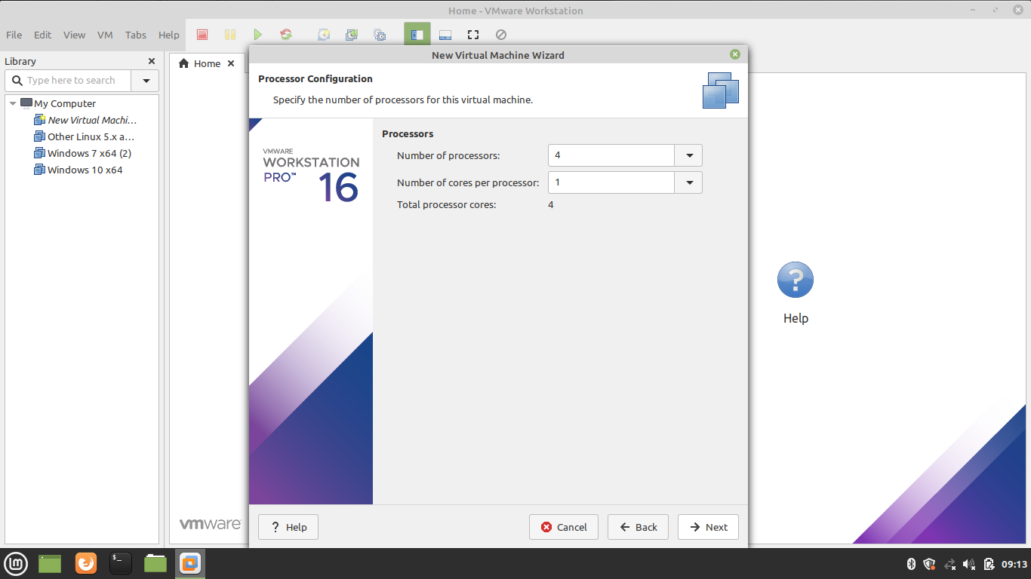

1. Allocate the Memory for Virtual Machine

Memory allocation calculation is the same as the processor allocation. Leave sufficient memory for the host system and allocate the remaining memory for the virtual machine.  
  
  
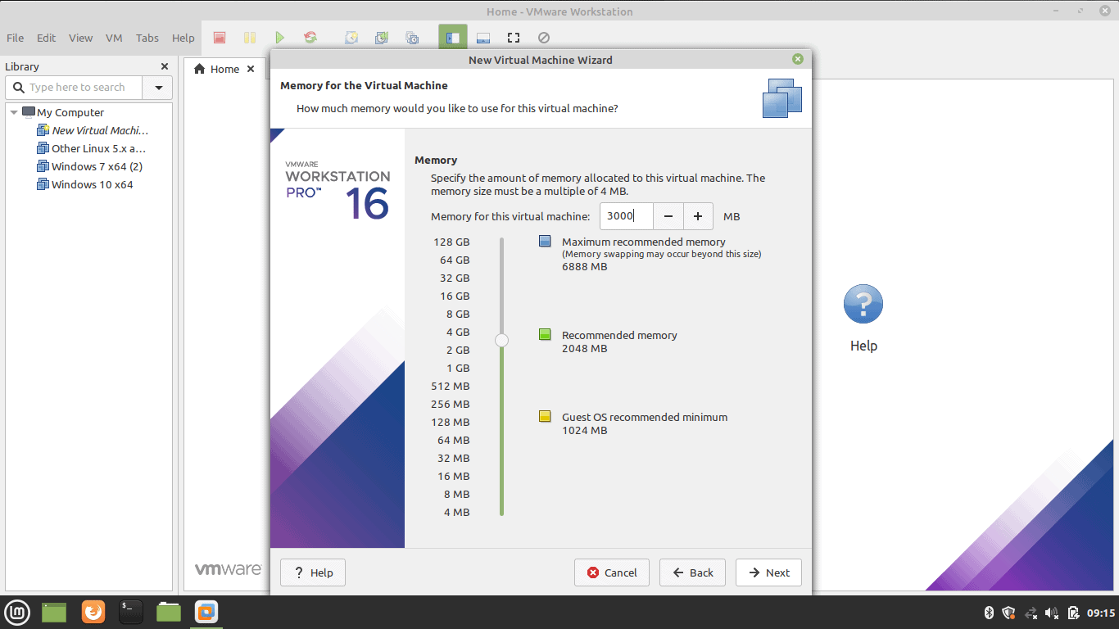

1. Choose the Network Configuration

Select any one of the network configurations as per our requirement.  
  
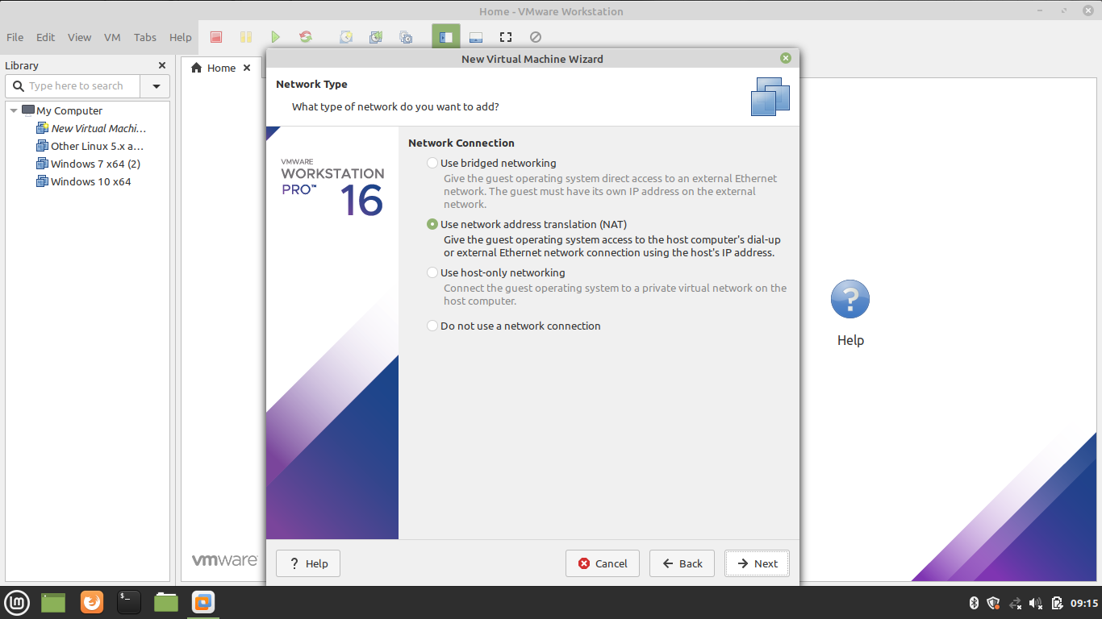

1. Select the I/O Controller Type

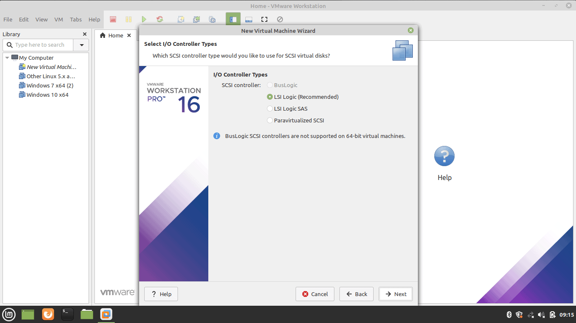

1. Select Disk Type

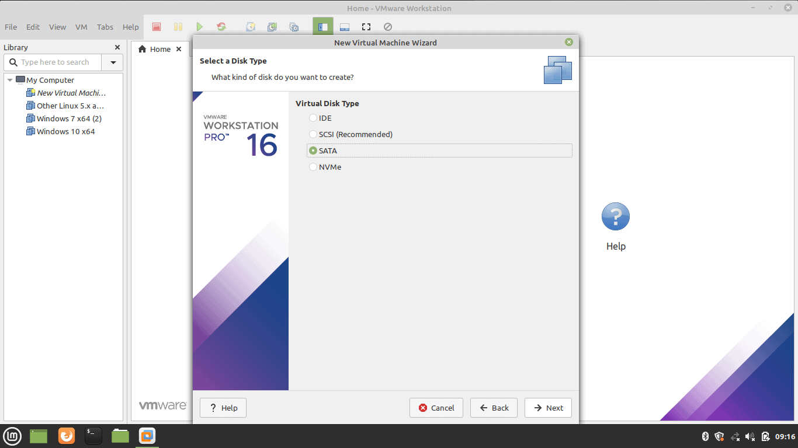

1. Select Virtual Disk

Select the Virtual Disk if we have or create one.  
  
  
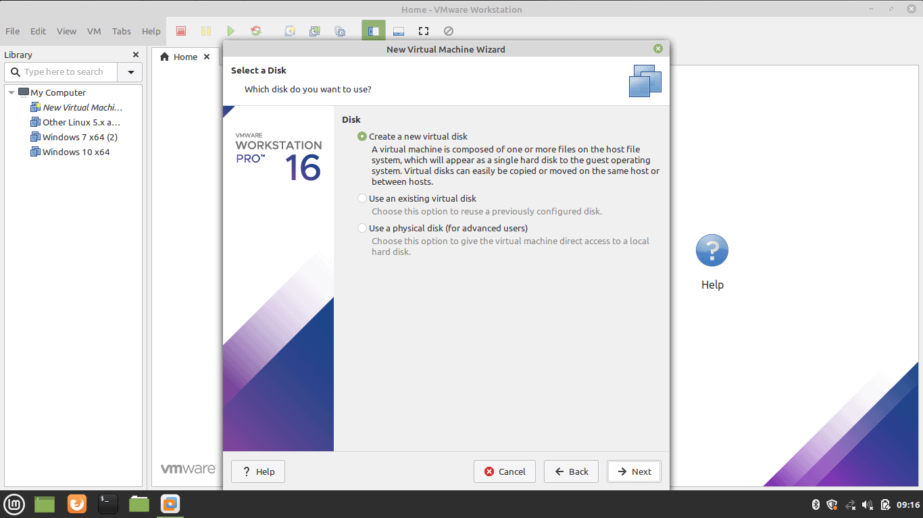

1. Select Disk Capacity

Select the disk size. Selecting a single disk will increase the performance. However, selecting a split disk will help in the disk transfer scenario.  
  
  
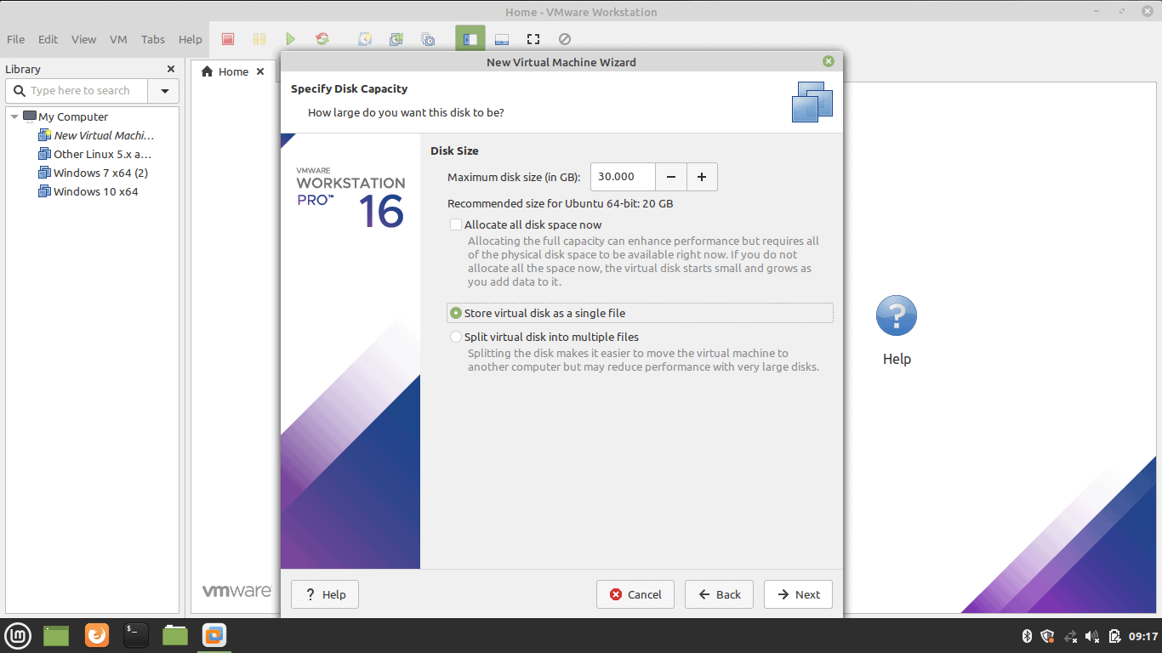

1. Specify Virtual Disk File

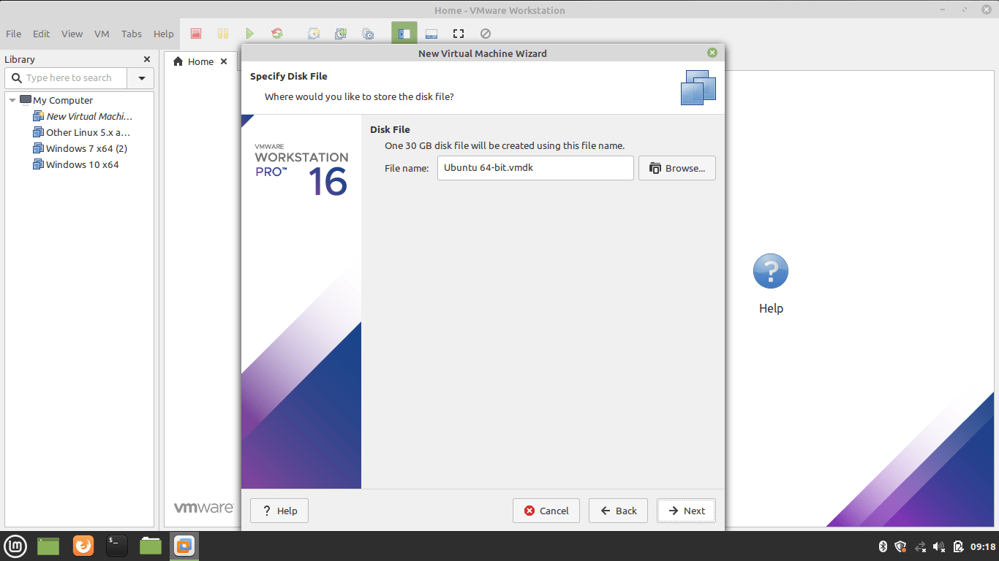

1. Create Virtual Machine

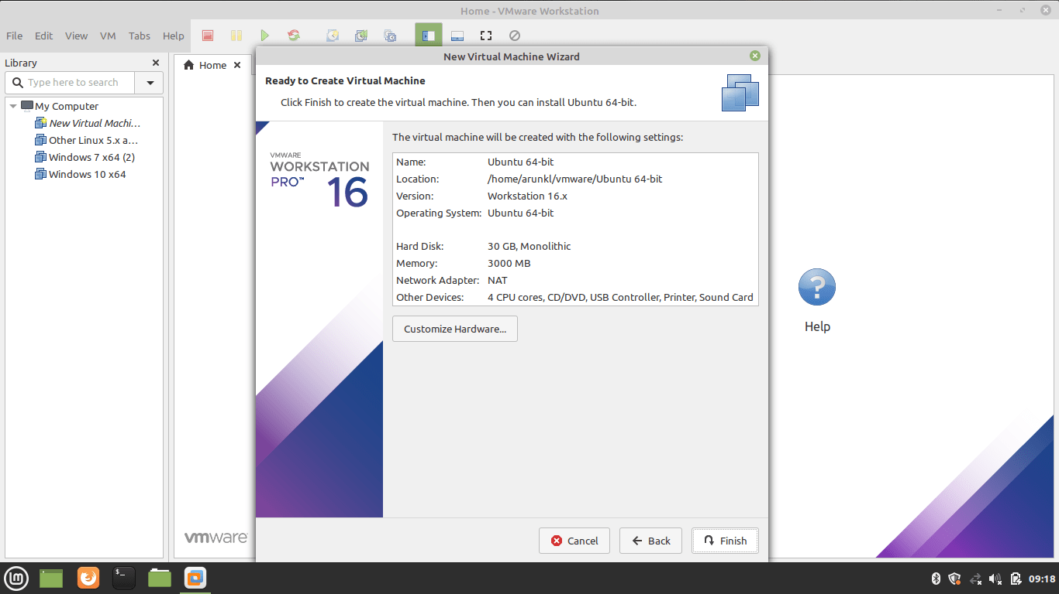

1. Supply Ubuntu ISO Image to Virtual Machine

Download Ubuntu image. Edit the CD/DVD settings and import the downloaded Ubuntu image.  
  
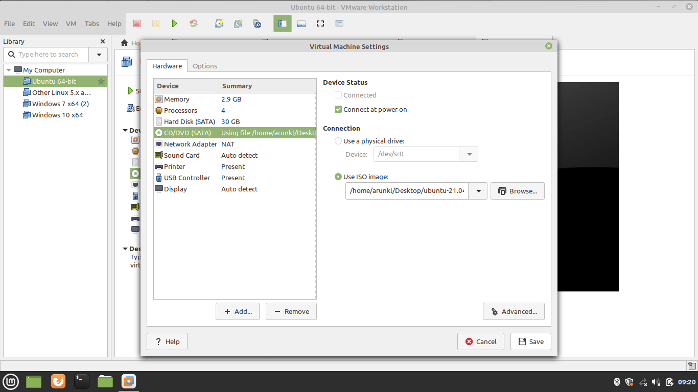

1. Install Ubuntu Linux on VMWare Workstation

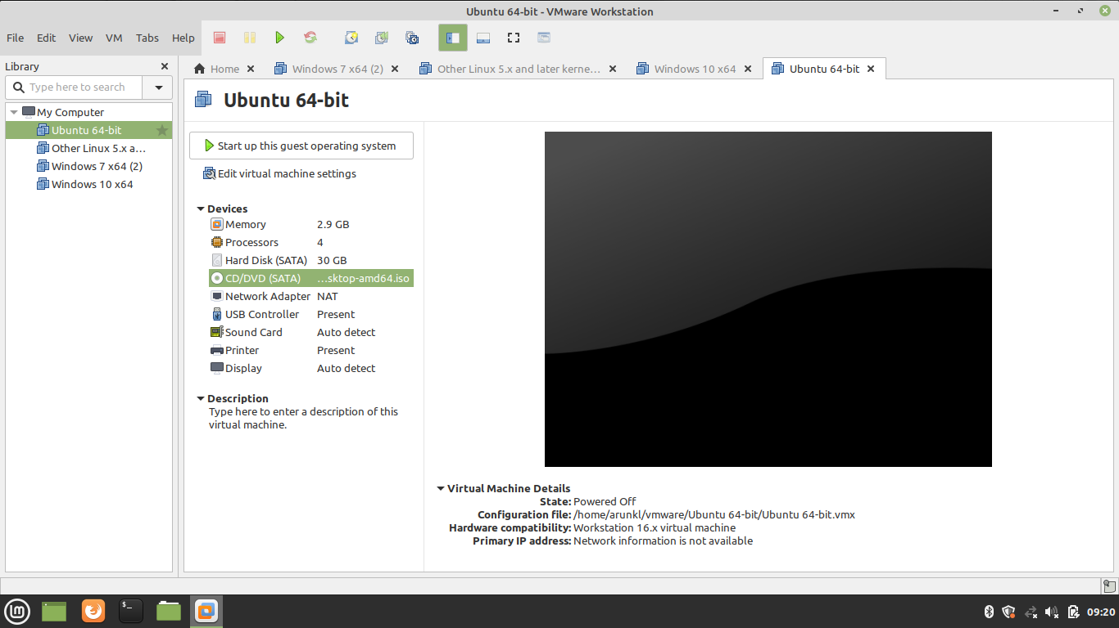

1. Power On the Virtual Machine

Press the Play button to power on the Virtual Machine.  
  
  
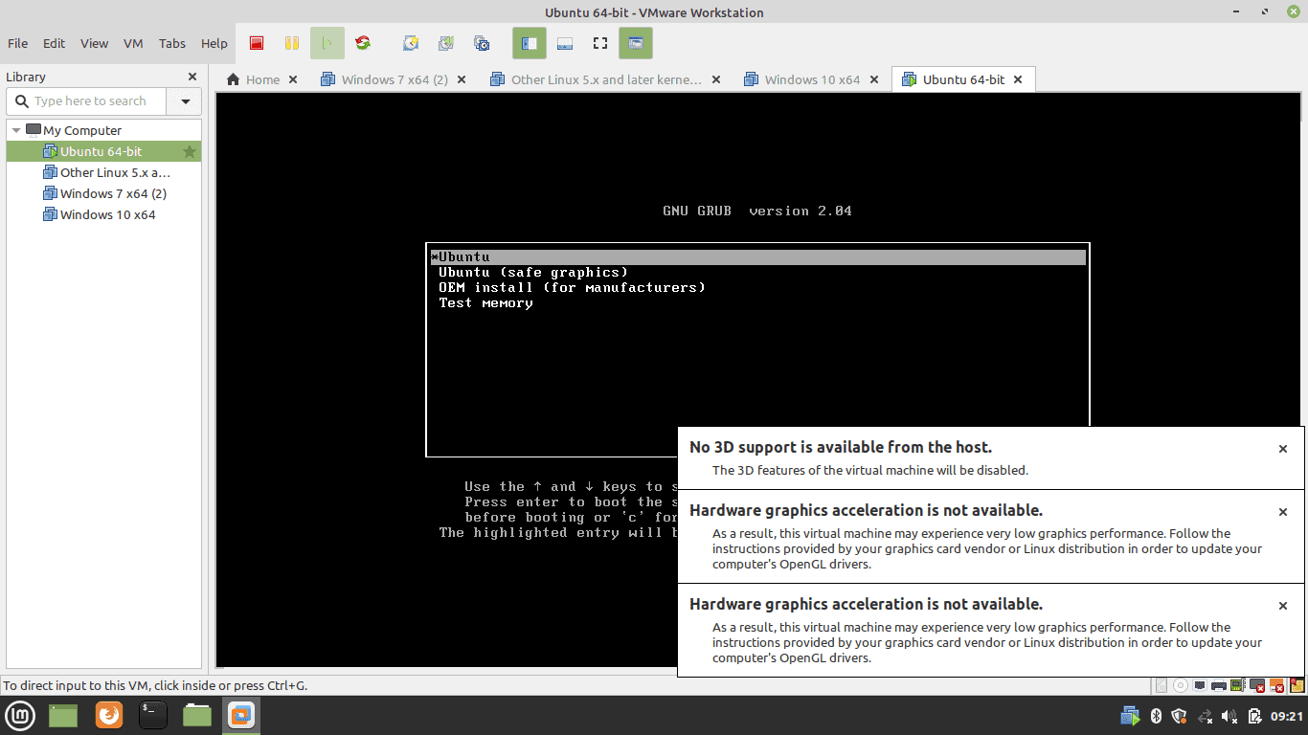

1. Welcome Ubuntu Virtual Machine

After powering on the Virtual machine, we will be treated with a welcome screen on which we will see two options: Try Ubuntu and Install Ubuntu. Select Try Ubuntu if we want to run Ubuntu in live mode. Select Install to continue the installation process.  
  
  
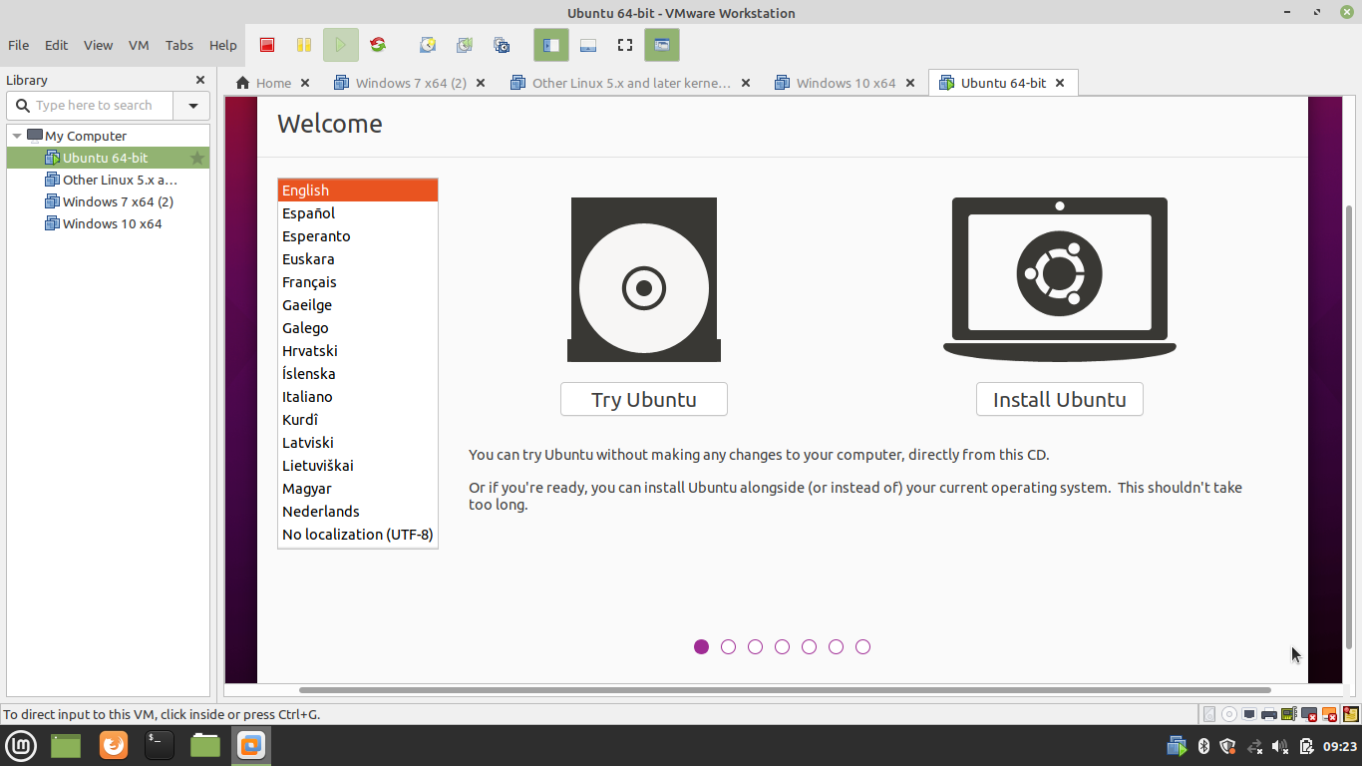

1. Select Keyboard Lawet

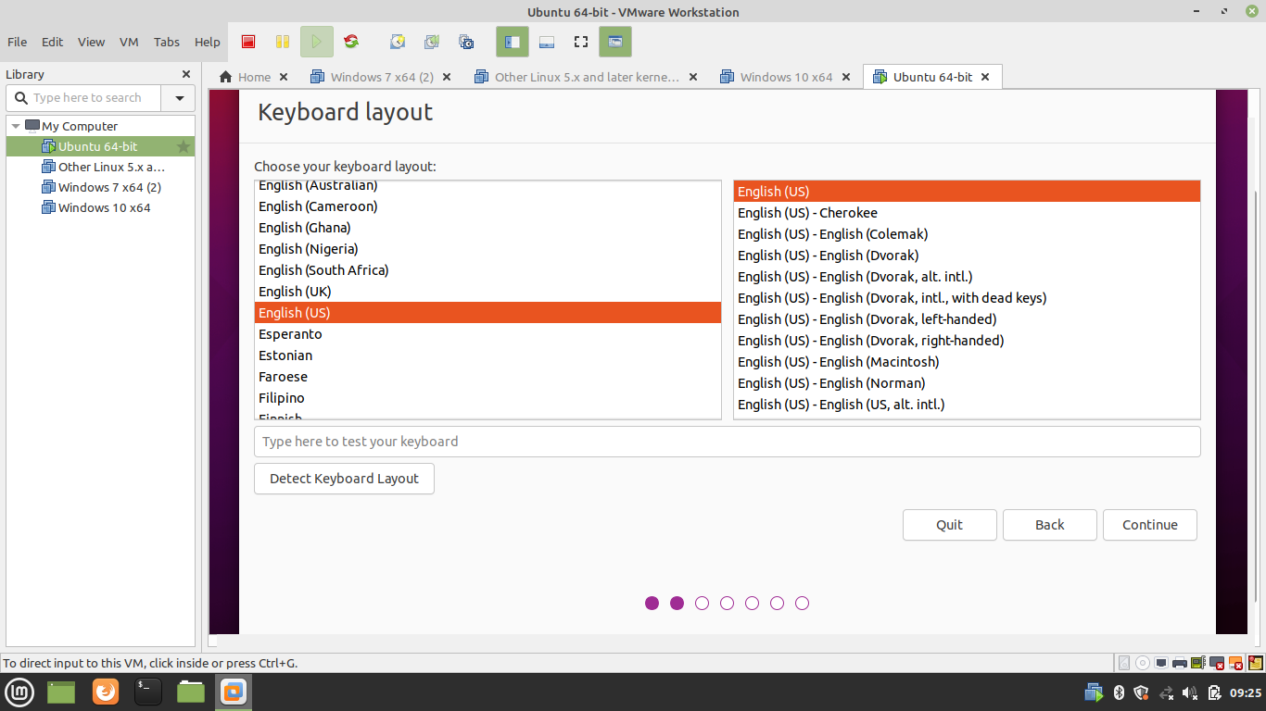

1. Software Update and Package Selection in Virtual Machine

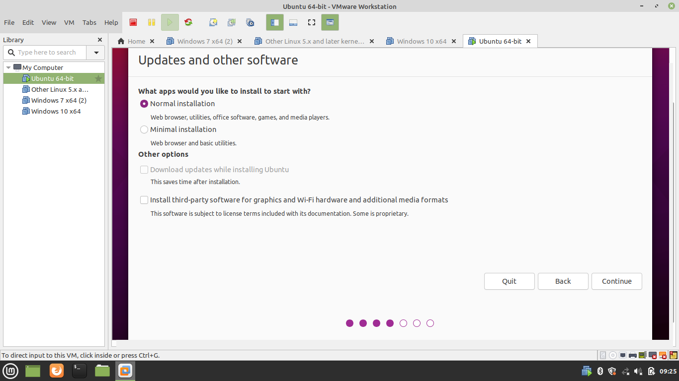

1. Partition the Disk

Select Erase the Disk for auto partition. Or Select the Advance option to create the custom partition.  
  
  
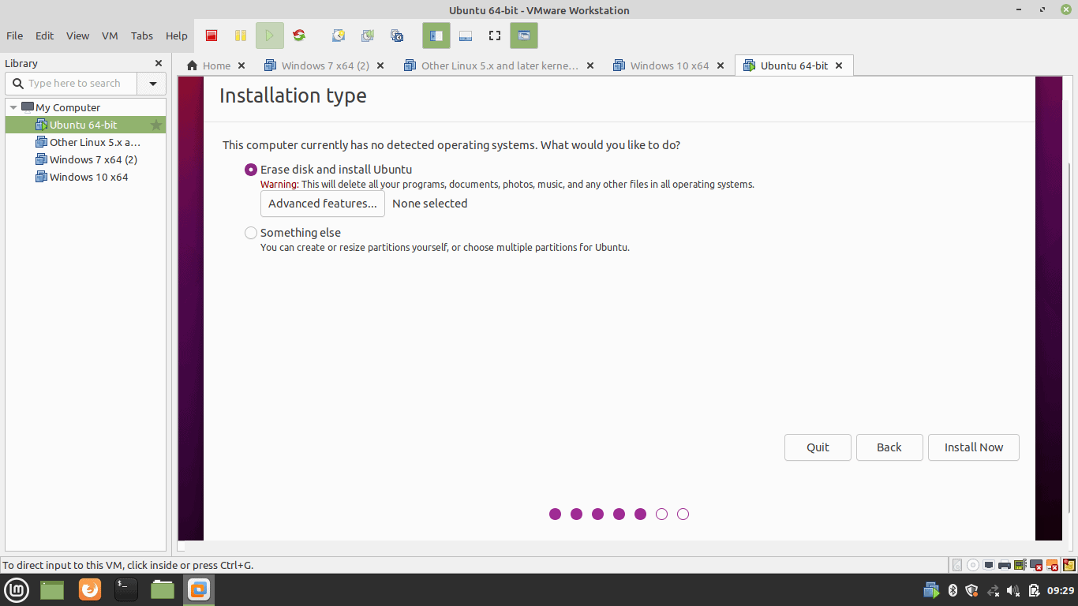

1. Write Changes to Disk

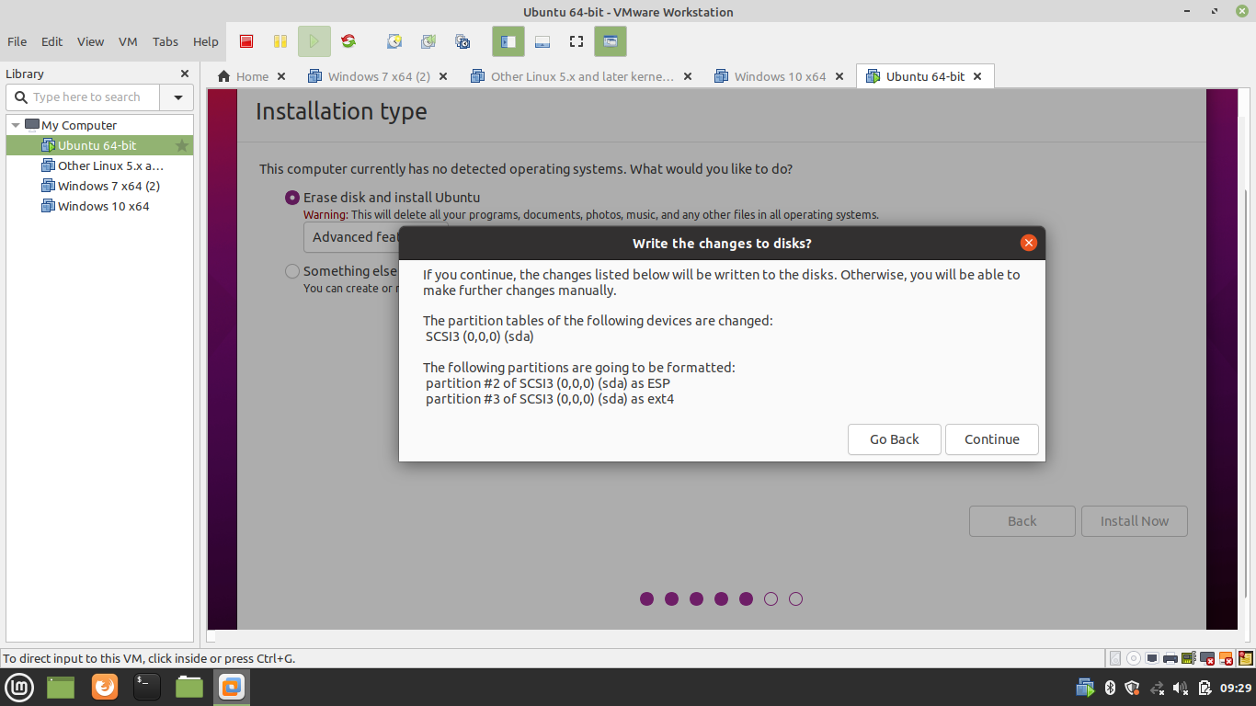

1. Select Time Zone

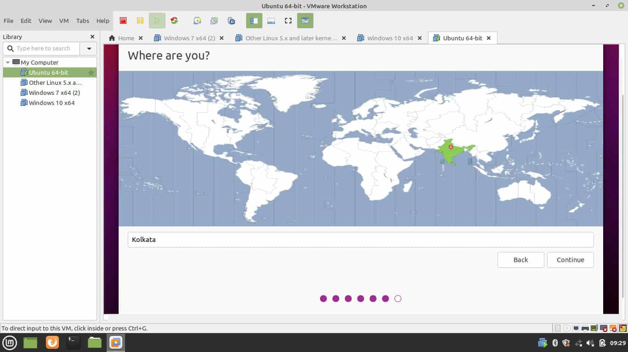

1. Create an Admin Account

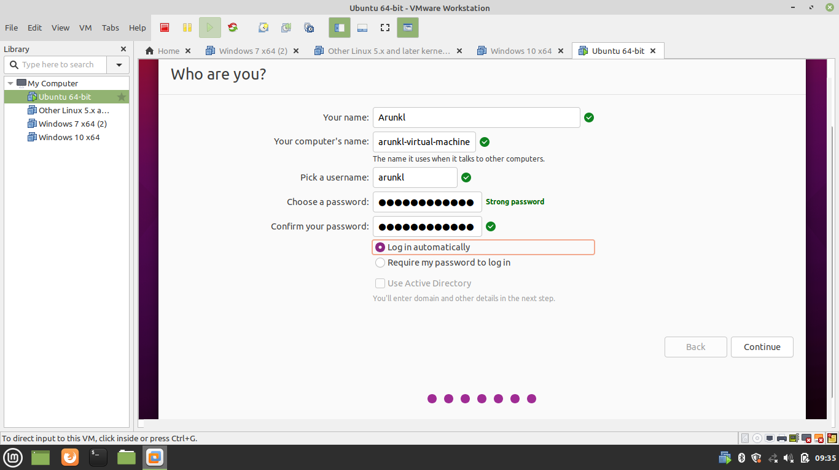

1. Installation of Ubuntu in Progress

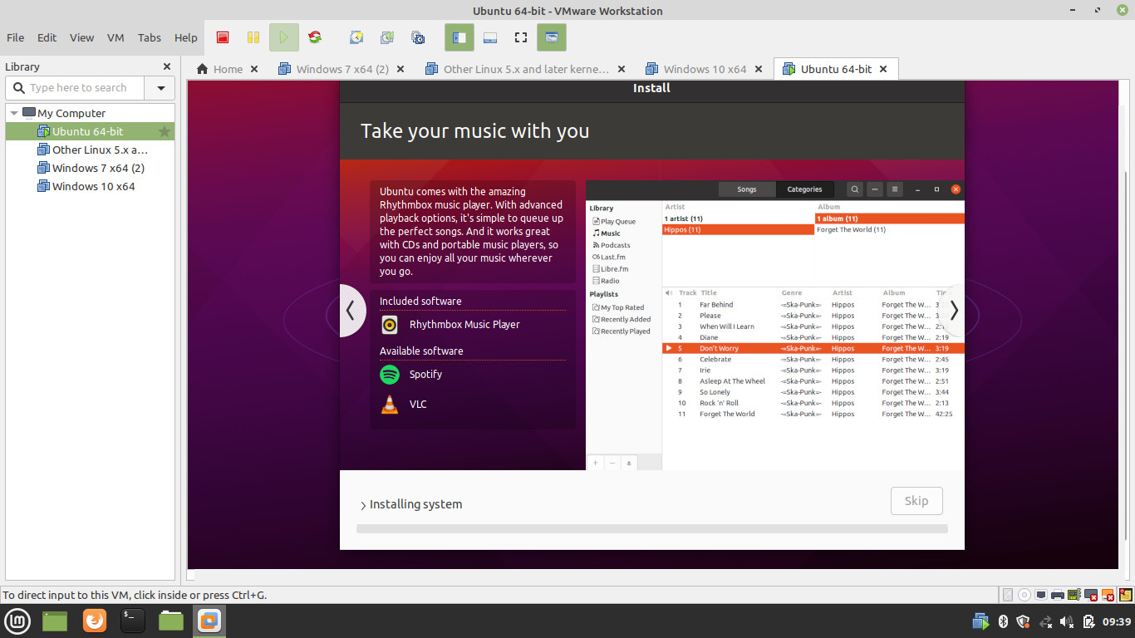

1. Reboot Virtual Machine

Reboot the machine after installation.  
  
  
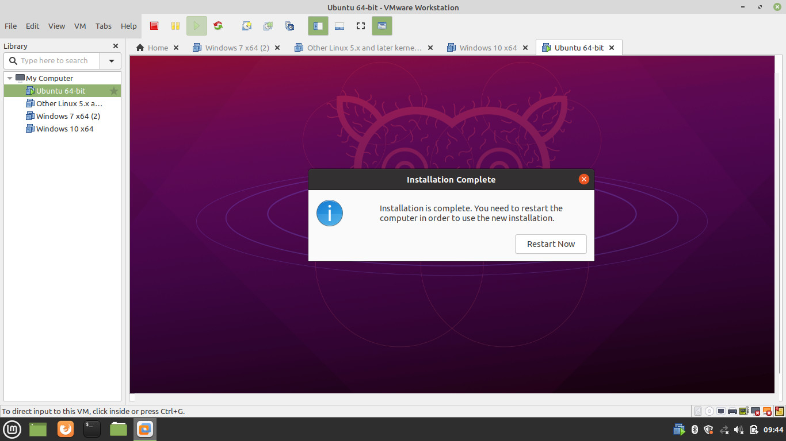

1. Remove the installation media

Remove the installation media before reboot.  
  
  
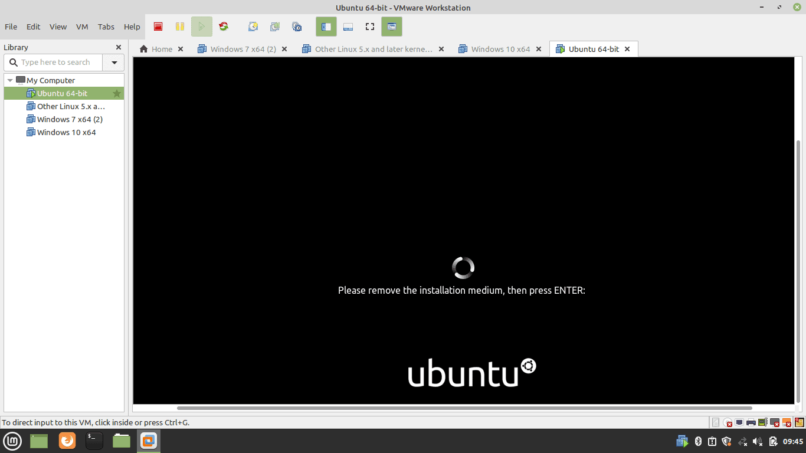

1. Boot Ubuntu

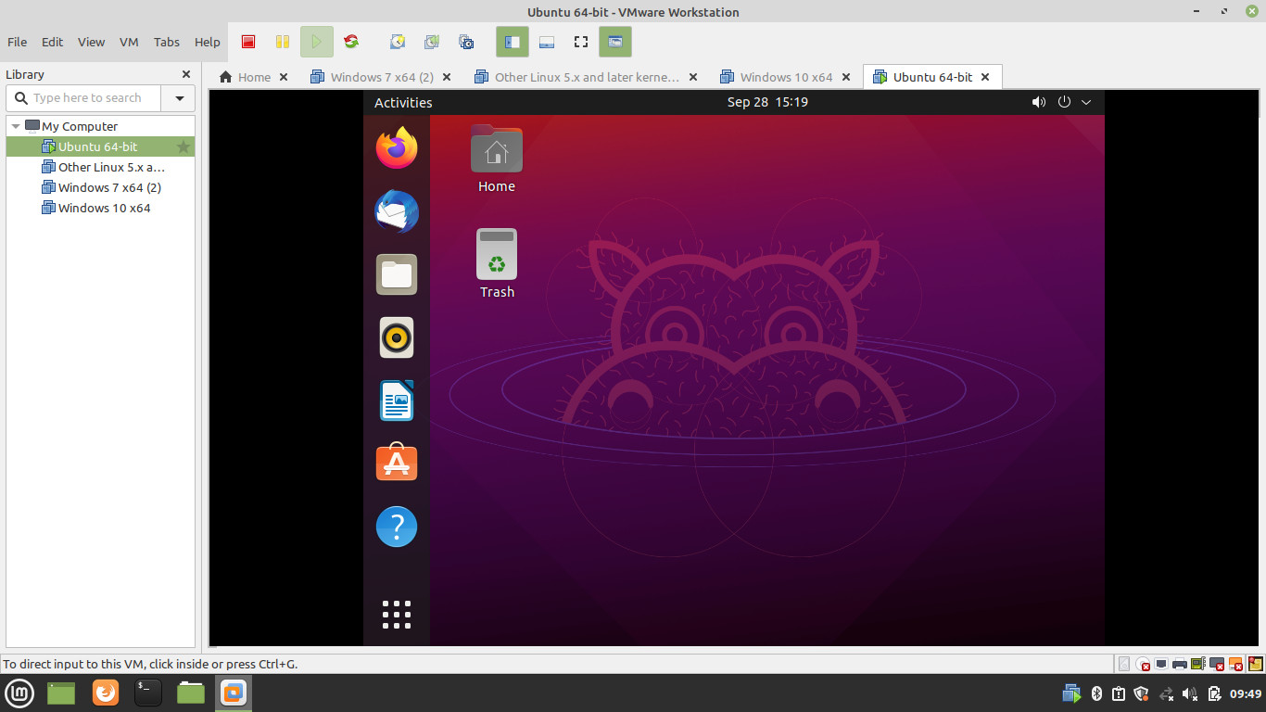

Basic 25 Unix shell commands:

1. pwd — When we first open the terminal, we are in the home directory of our user. To know which directory we are in, we can use the “pwd” command. It gives us the absolute path, which means the path that starts from the root. The root is the base of the Linux file system. It is denoted by a forward slash( / ). The user directory is usually something like "/home/username".

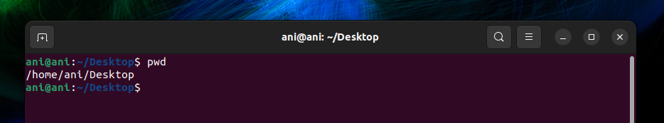

2. ls — Use the "ls" command to know what files are in the directory we are in. We can see all the hidden files by using the command “ls -a”.

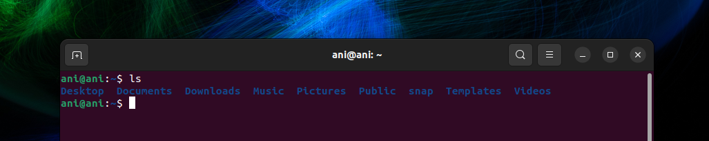

3. cd — Use the "cd" command to go to a directory. For example, if we are in the home folder, and we want to go to the downloads folder, then we can type in “cd Downloads”. Remember, this command is case sensitive, and we have to type in the name of the folder exactly as it is.

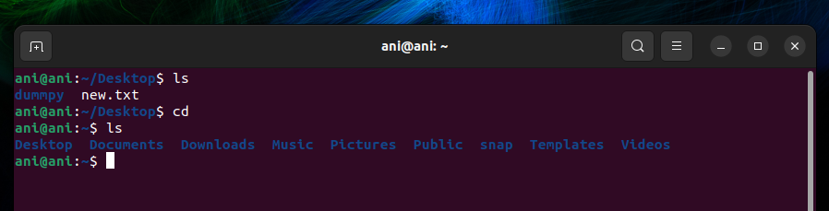

4. mkdir — Use the mkdir command when we need to create a folder or a directory. For example, if we want to make a directory called “DIY”, then we can type “mkdir DIY”. Remember, as told before, if we want to create a directory named “DIY Hacking”, then we can type “mkdir DIY\ Hacking”.

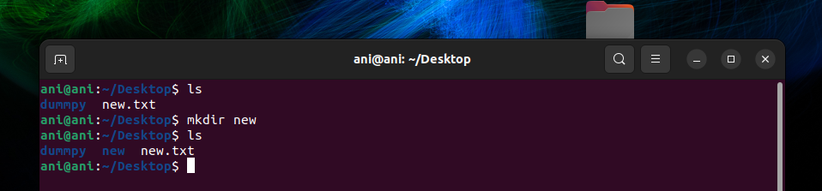

5. rmdir —Use rmdir to delete a directory. But rmdir can only be used to delete an empty directory. To delete a directory containing files, use rm.

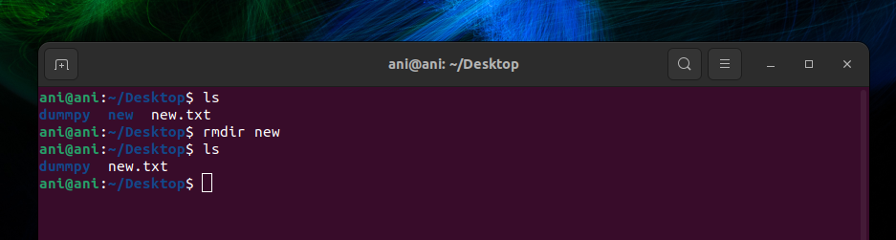

6. touch — The touch command is used to create a file. It can be anything, from an empty txt file to an empty zip file. For example, “touch new.txt”.

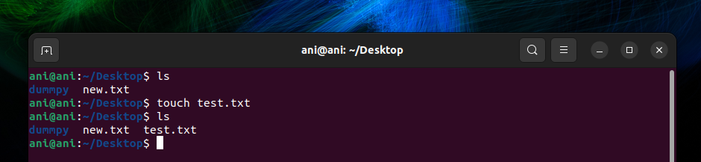

7. rm - Use the rm command to delete files and directories.  Use "rm -r" to delete just the directory. It deletes both the folder and the files it contains when using only the rm command.

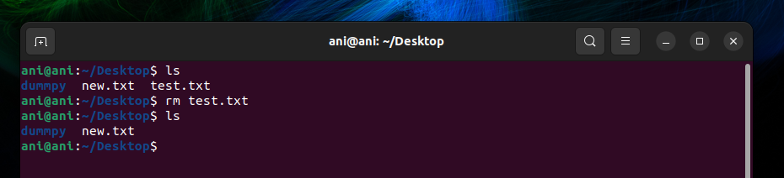

8. man— To know more about a command and how to use it, use the man command. It shows the manual pages of the command. For example, “man rm” shows the manual pages of the rm command.

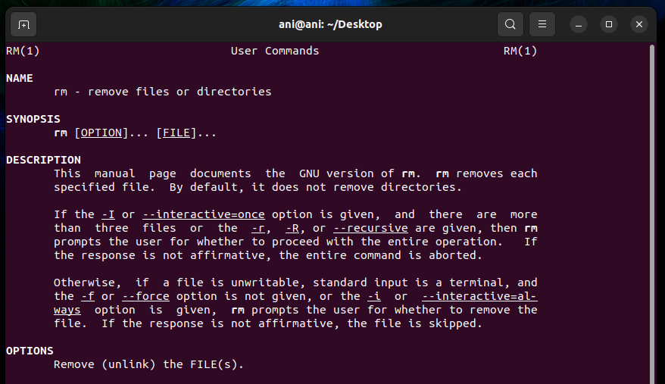

9. cp — Use the cp command to copy files through the command line. It takes two arguments: The first is the location of the file to be copied, the second is where to copy.

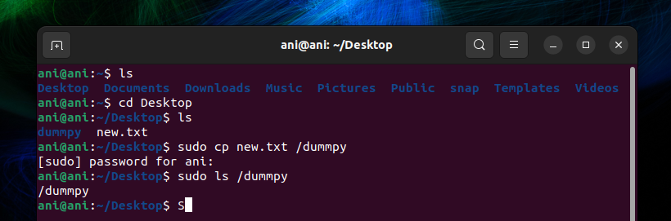

10. mv — Use the mv command to move files through the command line. We can also use the mv command to rename a file. For example, if we want to rename the file “text” to “new”, we can use “mv text new”.

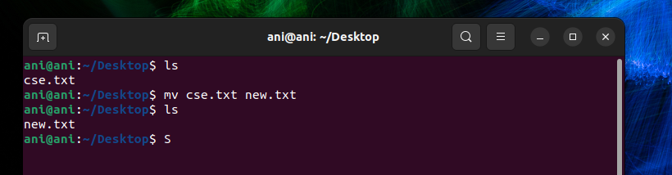

11. locate — The locate command is used to locate a file in a Linux system, just like the search command in Windows. This command is useful when we don't know where a file is saved or the actual name of the file. Using the -i argument with the command helps to ignore the case (it doesn't matter if it is uppercase or lowercase). So, if we want a file that has the word “hello”, it gives the list of all the files in our Linux system containing the word "hello" when we type in “locate -i hello”

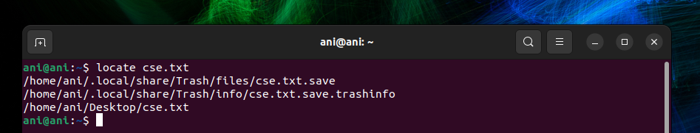

12. echo — The "echo" command helps us move some data, usually text into a file.

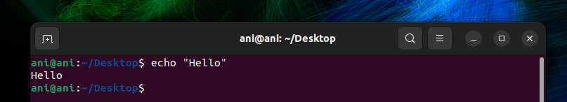

13. cat — Use the cat command to display the contents of a file. It is usually used to easily view programs.

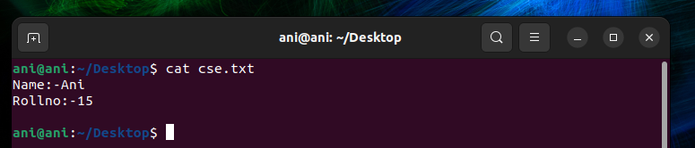

14. nano — nano is already installed text editors in the Linux command line. The nano command is a good text editor that denotes keywords with color and can recognize most languages.

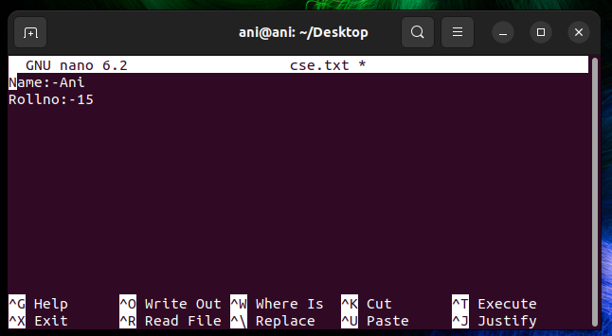

15. and (&&): — and“and” command in linux which is used to combine two more commands

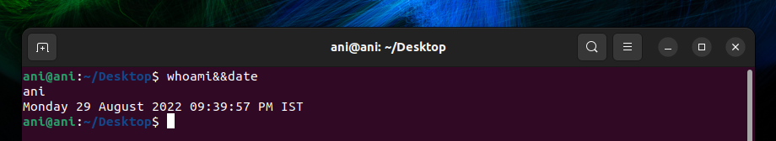

16. df — Use the df command to see the available disk space in each of the partitions in our system. We can just type in df in the command line and we can see each mounted partition and their used/available space in % and in KBs. If we want it shown in megabytes, we can use the command “df -m”.

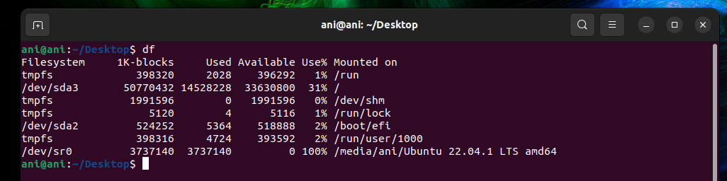

17. du — Use du to know the disk usage of a file in our system. If we want to know the disk usage for a particular folder or file in Linux, we can type in the command df and the name of the folder or file. For example, if we want to know the disk space used by the documents folder in Linux, we can use the command “du Documents”. We can also use the command “ls -lah” to view the file sizes of all the files in a folder.

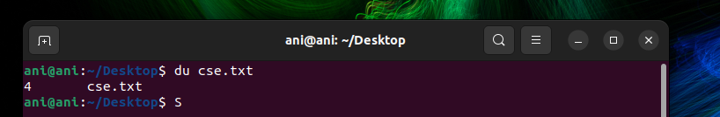

18. tty – Use tty to show the current display path name.



19.date: — Using date command we can see the system date and time in the given format.

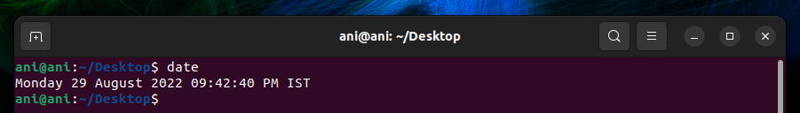

20.Seq – Using seq command in linux we can print a sequence in terminal using initial and final values given by us

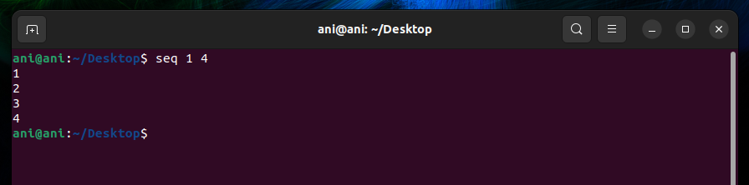

21. uname — Use uname to show the information about the system our Linux distro is running. Using the command “uname -a” prints most of the information about the system. This prints the kernel release date, version, processor type, etc.

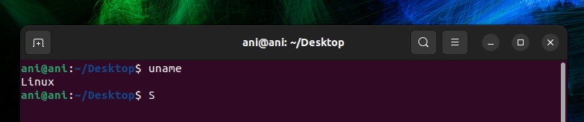

22. Whoami: — using “whoami” command in linux we can find the name of current user.

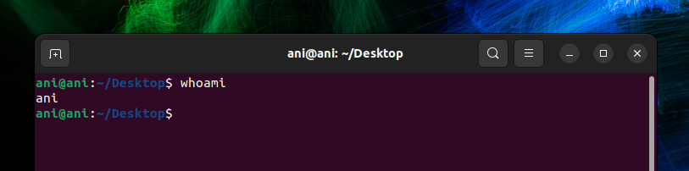

23. Basic calculator- Using “bc” command in linux terminal we can access basic calculator

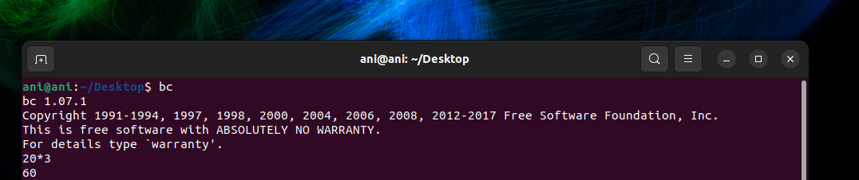

24. hostname — Using hostname gives us our name in our host or network. It displays our hostname and IP address. Typing “hostname” gives the output. Typing in “hostname -I” gives we our IP address in our network.

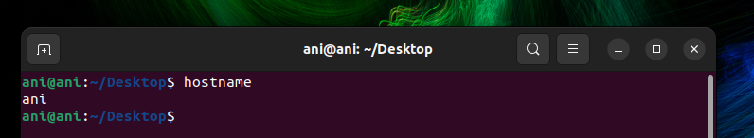

25. ping — Use ping to check our connection to a server. when we type in, for example, “ping google.com”, it checks if it can connect to the server and come back. It measures this round-trip time and gives we the details about it. The use of this command for simple users like us is to check our internet connection. If it pings the Google server (in this case), we can confirm that our internet connection is active.

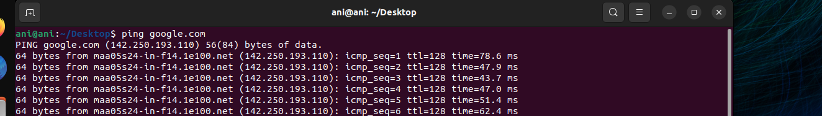

Result:

We have performed 25 unix shell commands in ubuntu terminal and recorded their output

**Exp No:** 2(a)  **Name:** PONNURI ANIRUDDHA

**Date:**16/08/2022 **Reg No:** RA2112704010015

**Process Creation using fork ()**

**and Usage of getpid (), getppid (), wait () functions**

**Aim: --**

To create process using fork () and Usage of getpid (), getppid (), wait () functions.

**Procedure: --**

1)Fork (): -

fork () system call is used to create child processes in a C program. fork () is used where parallel processing is required in your application. The fork () system function is defined in the headers sys/types.h and unistd.h

2)getpid (): -

It returns the process ID (PID) of the calling process.

3)getppid (): -

It returns the process ID of the parent of the calling process.

4)Wait (): -

The wait () system call suspends execution of the calling thread until one of its children terminates.

**Program: -**

*#include <sys/types.h>*

*#include <stdio.h>*

*#include <unistd.h>*

*#include <sys/wait.h>*

*#include <stdlib.h>*

*int main(int argc, char *argv[])*

*{*

*printf("I am: %d\n", (int) getpid());*

*pid_t pid = fork();*

*printf("fork returned: %d\n", (int) pid);*

*if (pid < 0) {*

*perror("Fork failed");*

*}*

*if (pid == 0) {*

*printf("I am the child with pid %d\n", (int) getpid());*

*printf("Child process is exiting\n");*

*exit(0);*

*}*

*printf("I am the parent waiting for the child process to end\n");*

*wait(NULL);*

*printf("parent process is exiting\n");*

*return(0);*

*}*

**OUTPUT: --**

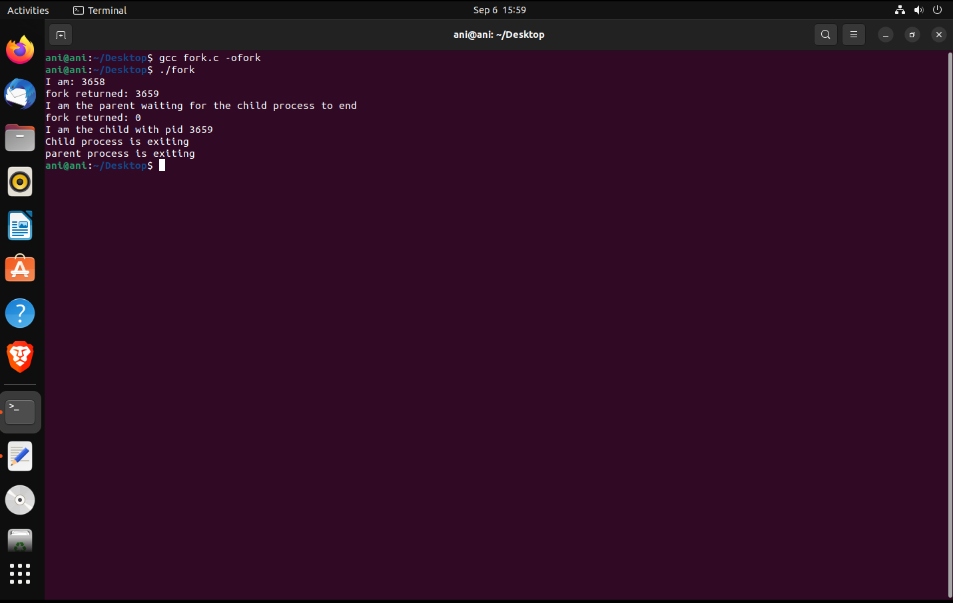

**Result: -**

Thus, we have successfully created process using fork () and Usage of getpid (),

getppid (), wait () functions.

**Exp No:** 2(b)  **Name:** PONNURI ANIRUDDHA

**Date:**16/08/2022 **Reg No:** RA2112704010015

**Zombie Process And Orphan Process**

**Aim: --**

To create zombie and orphan process using c programming

**Procedure: --**

**Zombie Process**

A zombie process is a process whose execution is completed but it still has an entry in the process table. Zombie processes usually occur for child processes, as the parent process still needs to read its child’s exit status. Once this is done using the wait system call, the zombie process is eliminated from the process table. This is known as reaping the zombie process

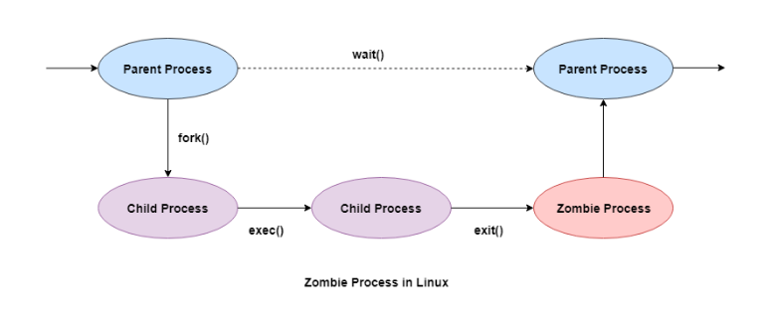

**Orphan Process: --**

A process whose parent process no more exists i.e., either finished or terminated without waiting for its child process to terminate is called an orphan process. Parent process finishes execution and exits while the child process is still executing and is called an orphan process.

**Code (Zombie Process): --**

*#include <stdio.h>*

*#include <stdlib.h>*

*#include<sys/wait.h>*

*#include<unistd.h>*

*int main() {*

*int pid = fork();*

*if (pid > 0) {*

*sleep(20);*

*printf("Parent process is exiting\n");*

*}*

*else {*

*printf("Child process is exiting\n");*

*printf("This is now considered as zombie process\n");*

*exit(0);*

*}*

*return 0;*

*}*

**Output (Zombie Process): --**

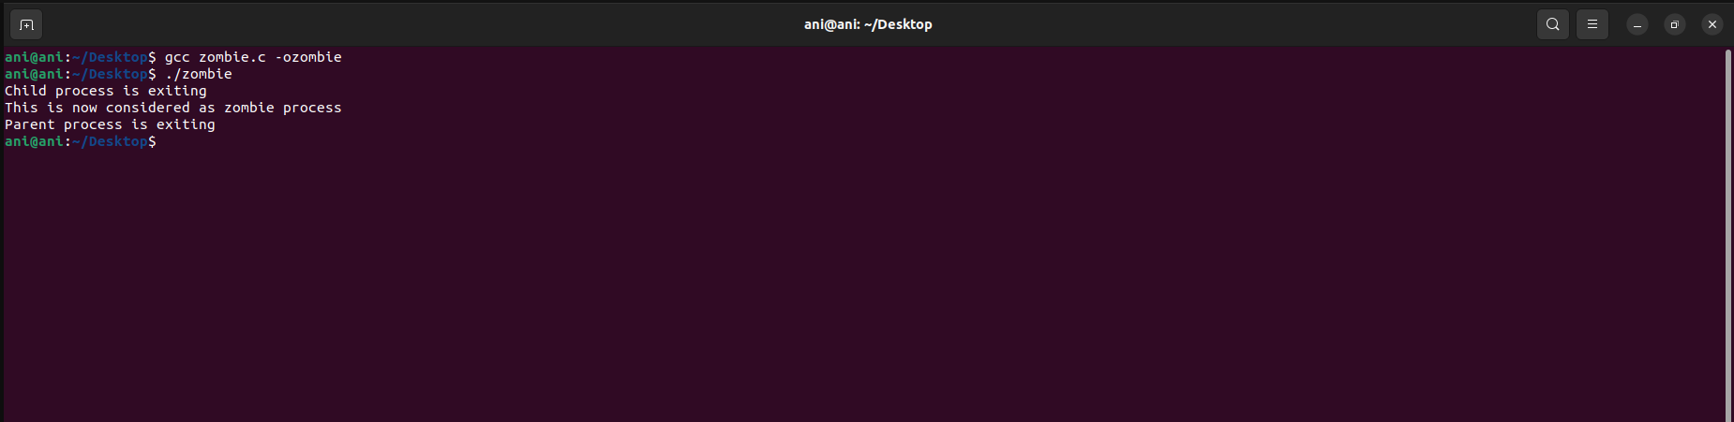

**Code (Orphan Process): --**

*#include<stdio.h>*

*#include <sys/types.h>*

*#include <unistd.h>*

*int main() {*

*int pid;*

*pid = fork();*

*if(pid == 0)*

*{*

*printf("I am the child, my process ID is %d\n",getpid());*

*printf("My parent's process ID is %d\n",getppid());*

*sleep(2);*

*printf("\nAfter sleep\nI am the child, my process ID is %d\n",getpid());*

*printf("My parent's process ID is %d\n",getppid());*

*exit(0);*

*}*

*else*

*{*

*sleep(3);*

*printf("I am the parent, my process ID is %d\n",getpid());*

*printf("Parent terminates\n");*

*}*

*return 0;*

*}*

**Output (Orphan Process): --**

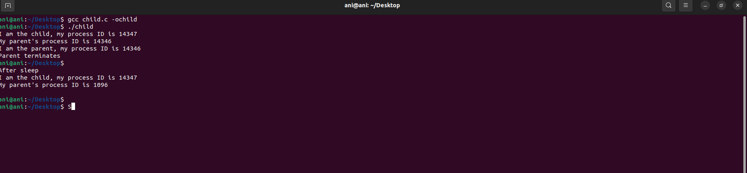

**Result: -**

Thus we have successfully created Zombie process and Orphan Process.

**Exp No.**3: **Name:** PONNURI ANIRUDDHA

**Date:**23/08/2022 **Reg No:** RA2112704010015

**Multithreading and pthread in C**

**Aim: --**

Creation of Multithreading using posix threads in C

**Procedure: --**

Thread:

A Thread is a single sequence stream within a process. In short thread is a unit of process.

Multithreading:

Multithreading is the ability of a program or an operating system to enable more than one user at a time without requiring multiple copies of the program running on the computer. Multithreading can also handle multiple requests from the same user.

POSIX threads:

The POSIX thread libraries are a C/C++ thread API based on standards. It enables the creation of a new concurrent process flow. It works well on multi-processor or multi-core systems, where the process flow may be scheduled to execute on another processor, increasing speed through parallel or distributed processing. Because the system does not create a new system, virtual memory space and environment for the process, threads need less overhead than “forking” or creating a new process. While multiprocessor systems are the most effective, benefits can also be obtained on uniprocessor systems that leverage delay in I/O and other system processes that may impede process execution

CODE: --

*#include <stdio.h>*

*#include <stdlib.h>*

*#include <unistd.h>*

*#include <pthread.h>*

*void *threadCreation(void *vargp)*

*{*

*sleep(1);*

*printf("A new thread is created \n");*

*return NULL;*

*}*

*int main()*

*{*

*pthread_t thread_id;*

*printf("Before Thread\n");*

*pthread_create(&thread_id, NULL, threadCreation, NULL);*

*pthread_join(thread_id, NULL);*

*printf("The Thread ID is of thread is %ld\n",thread_id);*

*printf("After Thread\n");*

*exit(0);*

*}*

**Output: --**

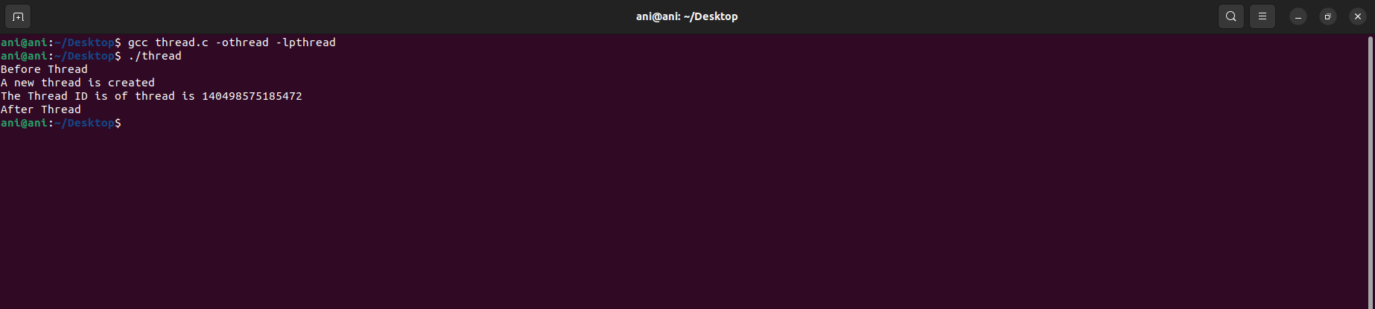

**Result: --**

A thread is created using Multithreading concept using posix threads.

**Exp No** 4: **Name**:qPONNURI ANIRUDDHA

**Date**:30/08/2022 **Reg No**: RA2112704010015

# **Mutual Exclusion using semaphore and monitor**

**Aim: –**

Multithreading using Mutual exclusion using semaphore and monitor

**Procedure: –**

Thread synchronization

Thread synchronization is defined as a mechanism which ensures that two or more concurrent processes or threads do not simultaneously execute some particular program segment known as a critical section. Processes’ access to critical section is controlled by using synchronization techniques. When one thread starts executing thecritical section (a serialized segment of the program) the other thread should wait until the first thread finishes. If proper synchronization techniques are not applied, it may cause a race condition where the values of variables may be unpredictable and vary depending on the timings of context switches of the processes or threads.

Mutex: --

1. A Mutex is a lock that we set before using a shared resource and release after using it.
2. When the lock is set, no other thread can access the locked region of code.
3. So, we see that even if thread 2 is scheduled while thread 1 was not done accessing the shared resource and the code is locked by thread 1 using mutexes then thread 2 cannot even access that region of code.
4. So, this ensures synchronized access of shared resources in the code.

Mutual Exclusion using semaphore

A semaphore is an integer variable that allows many processes in a parallel system to manage access to a common resource like a multitasking OS. It is an integer variable (S), and it is initialized with the number of resources in the system. The wait() and signal() methods are the only methods that may modify the semaphore (S) value. When one process modifies the semaphore value, other processes can't modify the semaphore value simultaneously.

Semaphore*s* are an abstract entity provided by an operating system (not the hardware). Semaphores:

* are named by a unique semaphore id
* consist of a tuple (id, count, queue), where count is an integer and queue are a list of processes.
  + a non-negative count always means that the queue is empty
  + a count of negative n indicates that the queue contains n waiting processes.
  + a count of positive n indicates that n resources are available and n requests can be granted without delay.
* sem = semcreate(val) -- creates a semaphore with the given initial value
* semdelete(sem) -- delete a semaphore
* wait(sem) -- decrement the semaphore count. if negative, suspend the process and place in queue. (Also referred to as P())
* signal(sem) -- increment the semaphore count, allow the first process in the queue to continue. (Also referred to as V())

Mutual Exclusion using Monitor

It is a synchronization technique that enables threads to mutual exclusion and the wait() for a given condition to become true. It is an abstract data type. It has a shared variable and a collection of procedures executing on the shared variable. A process may not directly access the shared data variables, and procedures are required to allow several processes to access the shared data variables simultaneously.

At any particular time, only one process may be active in a monitor. Other processes that require access to the shared variables must queue and are only granted access after the previous process releases the shared variables.

The monitor is made up of four primary parts:

* Initialization: The code for initialization is included in the package, and we just need it once when creating the monitors.
* Private Data: It is a feature of the monitor in an operating system to make the data private. It holds all of the monitor's secret data, which includes private functions that may only be utilized within the monitor. As a result, private fields and functions are not visible outside of the monitor.
* Monitor Procedure: Procedures or functions that can be invoked from outside of the monitor are known as monitor procedures.
* Monitor Entry Queue: Another important component of the monitor is the Monitor Entry Queue. It contains all of the threads, which are commonly referred to as procedures only.

**Code (MUTEX): –**

*#include <pthread.h>*

*#include <stdio.h>*

*#include <stdlib.h>*

*#include <string.h>*

*#include <unistd.h>*

*pthread_t tid[2];*

*int counter;*

*pthread_mutex_t lock;*

*void* threadFunction(void* arg)*

*{*

*pthread_mutex_lock(&lock);*

*unsigned long i = 0;*

*counter += 1;*

*printf("\n Job %d has started\n", counter);*

*for (i = 0; i < (0xFFFFFFFF); i++)*

*;*

*printf("\n Job %d has finished\n", counter);*

*pthread_mutex_unlock(&lock);*

*return NULL;*

*}*

*int main(void){*

*int i = 0;*

*int err;*

*while(i<2){*

*err = pthread_create(&(tid[i]), NULL, &doSomeThing, NULL);*

*if (err != 0)*

*printf("\ncan't create thread :[%s]", strerror(err));*

*i++;*

*}*

*pthread_join(tid[0], NULL);*

*pthread_join(tid[1], NULL);*

*return 0;*

*}*

**Output (MUTEX): --**

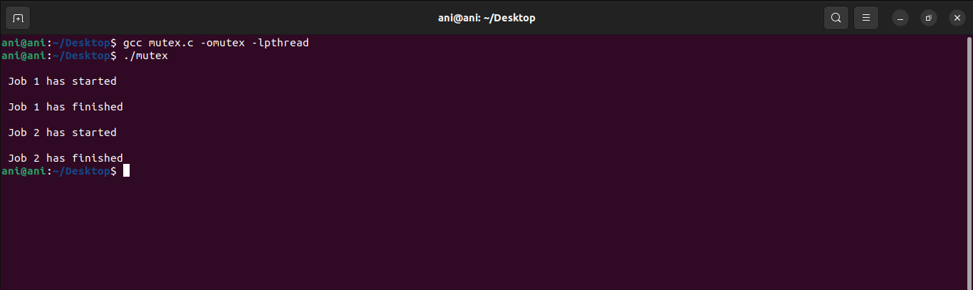

**Code (Semaphores): --**

*#include <stdio.h>*

*#include <pthread.h>*

*#include <semaphore.h>*

*#include <unistd.h>*

*sem_t mutex;*

*void* thread(void* arg)*

*{*

*//wait*

*sem_wait(&mutex);*

*printf("\nEntered..\n");*

*//critical section*

*sleep(4);*

*//signal*

*printf("\nJust Exiting...\n");*

*sem_post(&mutex);*

*}*

*int main()*

*{*

*sem_init(&mutex, 0, 1);*

*pthread_t t1,t2;*

*pthread_create(&t1,NULL,thread,NULL);*

*sleep(2);*

*pthread_create(&t2,NULL,thread,NULL);*

*pthread_join(t1,NULL);*

*printf("The Thread ID is of thread 1 is %ld\n",t1);*

*pthread_join(t2,NULL);*

*printf("The Thread ID is of thread 2 is %ld\n",t2);*

*sem_destroy(&mutex);*

*return 0;*

*}*

**Output(Semaphores): --**

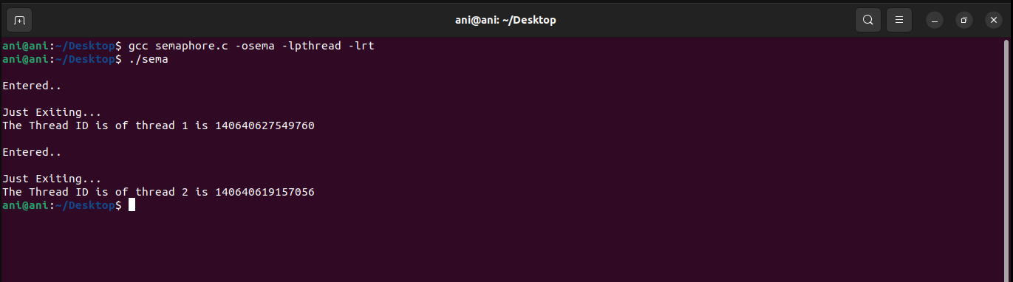

**Code (Monitors): --**

*import threading*

*import time*

*class testAndSet():*

*#lock variable used in test and set is defined here*

*Lock = 0*

*def test(self,*args):*

*if self.Lock == 0:*

*# The critical section goes here...*

*self.criticalsection(args[0])*

*else:*

*#while other process is executing current process is waiting*

*while self.Lock == 1:*

*print(f"Process {args[0]} waiting")*

*def criticalsection(self,i):*

*self.Lock = 1*

*print(f'Process {i} Entered Critical Section.\nPerform operation on*

*shared resource')*

*#exit section*

*self.Lock = 0*

*print(f'Process {i} exited Critical Section')*

*def main(self):*

*t1 = threading.Thread(target = self.test, args = (0,))*

*t1.start()*

*t2 = threading.Thread(target = self.test, args = (1,))*

*t2.start()*

*t3 = threading.Thread(target = self.test, args = (2,))*

*t3.start()*

*t4 = threading.Thread(target = self.test, args = (3,))*

*t4.start()*

*t5 = threading.Thread(target = self.test, args = (4,))*

*t5.start()*

*if __name__=="__main__":*

*t = testAndSet()*

*t.main()*

**Output (Monitors): --**

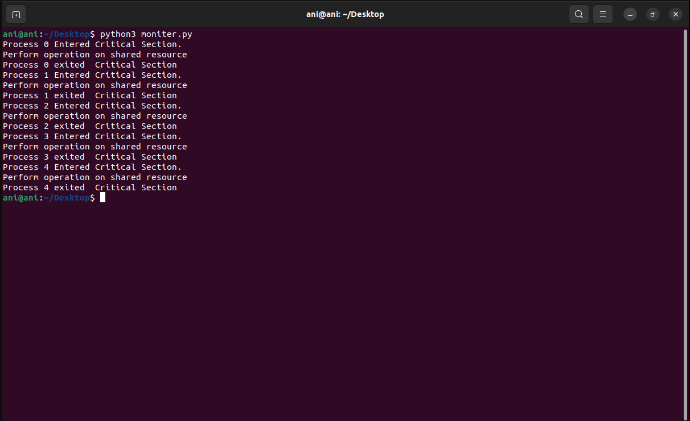

**Result: -**

Successfully executed Mutual Exclusion using semaphore and monitor

**Exp No.** 5 **Name:** PONNURI ANIRUDDHA

**Date**: 06/09/2022 **Reg No:** RA2112704010015

**Reader-Writer problem**

**Aim:**

Implementation of Reader-Writer problem

**Procedure:**

The readers-writers problem relates to an object such as a file that is shared between multiple processes. Some of these processes are readers i.e., they only want to read the data from the object and some of the processes are writers i.e., they want to write into the object. The readers-writers problem is used to manage synchronization so that there are no problems with the object data. For example - If two readers access the object at the same time there is no problem. However, if two writers or a reader and writer access the object at the same time, there may be problems.

To solve this situation, a writer should get exclusive access to an object i.e. when a writer is accessing the object, no reader or writer may access it. However, multiple readers can access the object at the same time.

**Code: --**

*#include<semaphore.h>*

*#include<stdio.h>*

*#include<stdlib.h>*

*#include<unistd.h>*

*#include<pthread.h>*

*sem_t x,y;*

*pthread_t tid;*

*pthread_t writerthreads[100],readerthreads[100];*

*int readercount = 0;*

*void *reader(void* param)*

*{*

*sem_wait(&x);*

*readercount++;*

*if(readercount==1)*

*sem_wait(&y);*

*sem_post(&x);*

*printf("%d reader is inside\n",readercount);*

*usleep(3);*

*sem_wait(&x);*

*readercount--;*

*if(readercount==0)*

*{*

*sem_post(&y);*

*}*

*sem_post(&x);*

*printf("%d Reader is leaving\n",readercount+1);*

*return NULL;*

*}*

*void *writer(void* param)*

*{*

*printf("Writer is trying to enter\n");*

*sem_wait(&y);*

*printf("Writer has entered\n");*

*sem_post(&y);*

*printf("Writer is leaving\n");*

*return NULL;*

*}*

*int main()*

*{*

*int n2,i;*

*printf("Enter the number of readers:");*

*scanf("%d",&n2);*

*printf("\n");*

*int n1[n2];*

*sem_init(&x,0,1);*

*sem_init(&y,0,1);*

*for(i=0;i<n2;i++)*

*{*

*pthread_create(&writerthreads[i],NULL,reader,NULL);*

*pthread_create(&readerthreads[i],NULL,writer,NULL);*

*}*

*for(i=0;i<n2;i++)*

*{*

*pthread_join(writerthreads[i],NULL);*

*pthread_join(readerthreads[i],NULL);*

*}*

*}*

**Output: --**

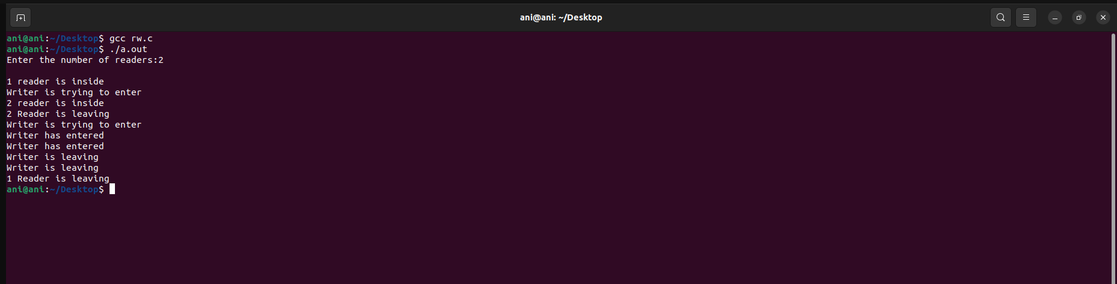

**Result: --**

Thus we come to know about Implementation of Reader-Writer problem using c.

**Exp No.** 6 **Name:** PONNURI ANIRUDDHA

**Date**: 13/09/2022 **Reg No:** RA2112704010015

**Dining Philosophers Problem**

**Aim: --**

To implement Dinning philosopher’s problem

**Procedure: --**

N philosophers, spend their time thinking and eating spaghetti. They eat at a round table with N individual seats. For eating each philosopher needs two forks (the resources). There are N forks on the table, one left and one right of each seat. When a philosopher cannot grab both forks it sits and waits. Eating takes random time, then the philosopher puts the forks down and leaves the dining room. After spending some random time thinking he again becomes hungry, and the circle repeats itself.

**CODE: --**

*import threading*

*import random*

*import time*

*#inheriting threading class in Thread module*

*class Philosopher(threading.Thread):*

*running = True #used to check if everyone is finished eating*

*def __init__(self, index, forkOnLeft, forkOnRight):*

*threading.Thread.__init__(self)*

*self.index = index*

*self.forkOnLeft = forkOnLeft*

*self.forkOnRight = forkOnRight*

*def run(self):*

*while(self.running):*

*# Philosopher is thinking (but really is sleeping).*

*time.sleep(30)*

*print ('Philosopher %s is hungry.' % self.index)*

*self.dine()*

*def dine(self):*

*# if both forks are free, then philosopher will eat*

*fork1, fork2 = self.forkOnLeft, self.forkOnRight*

*while self.running:*

*fork1.acquire() # wait operation on left fork*

*locked = fork2.acquire(False)*

*if locked: break #if right fork is not available leave left fork*

*fork1.release()*

*print ('Philosopher %s swaps forks.' % self.index)*

*fork1, fork2 = fork2, fork1*

*else:*

*return*

*self.dining()*

*#release both the fork after dining*

*fork2.release()*

*fork1.release()*

*def dining(self):*

*print ('Philosopher %s starts eating. '% self.index)*

*time.sleep(30)*

*print ('Philosopher %s finishes eating and leaves to think.' % self.index)*

*def main():*

*forks = [threading.Semaphore() for n in range(5)] #initialising array of semaphore i.e forks*

*#here (i+1)%5 is used to get right and left forks circularly between 1-5*

*philosophers= [Philosopher(i, forks[i%5], forks[(i+1)%5])*

*for i in range(5)]*

*Philosopher.running = True*

*for p in philosophers: p.start()*

*time.sleep(100)*

*Philosopher.running = False*

*print ("Now we're finishing.")*

*if __name__ == "__main__":*

*main()*

**Output: --**

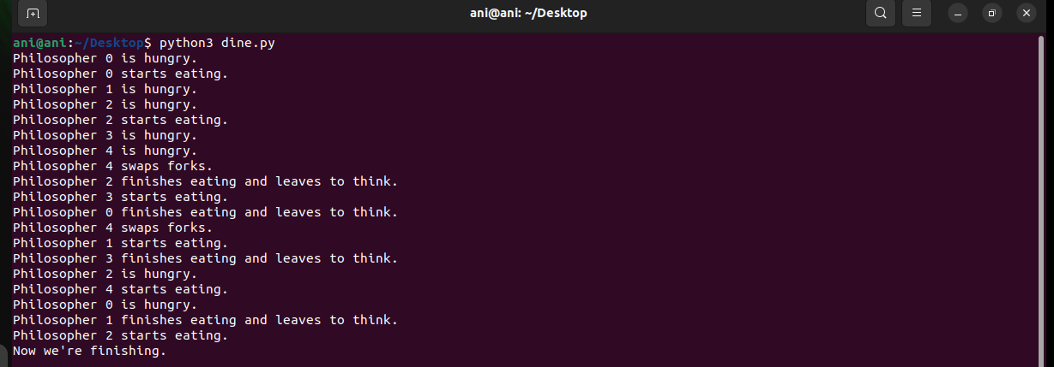

**Result: --**

We have successfully implemented dining philosopher’s problem in python

**Exp No.** 7 **Name:** PONNURI ANIRUDDHA

**Date**: 19/09/2022 **Reg No:** RA2112704010015

**Bankers Algorithm**

**Aim: --**

To implement Banker Algorithm

**Procedure: --**

The banker’s algorithm is a resource allocation and deadlock avoidance algorithm that tests for safety by simulating the allocation for predetermined maximum possible amounts of all resources, then makes an “s-state” check to test for possible activities, before deciding whether allocation should be allowed to continue.

Banker’s algorithm is named so because it is used in banking system to check whether loan can be sanctioned to a person or not. Suppose there are n number of account holders in a bank and the total sum of their money is S. If a person applies for a loan, then the bank first subtracts the loan amount from the total money that bank has and if the remaining amount is greater than S then only the loan is sanctioned. It is done because if all the account holders come to withdraw their money, then the bank can easily do it. In other words, the bank would never allocate its money in such a way that it can no longer satisfy the needs of all its customers. The bank would try to be in safe state always.

**CODE: --**

*# P0, P1, P2, P3, P4 are the Process names here*

*n = 5 # Number of processes*

*m = 3 # Number of resources*

*# Allocation Matrix*

*alloc = [[0, 1, 0 ],[ 2, 0, 0 ],[3, 0, 2 ],[2, 1, 1] ,[ 0, 0, 2]]*

*# MAX Matrix*

*max = [[7, 5, 3 ],[3, 2, 2 ],[ 9, 0, 2 ],[2, 2, 2],[4, 3, 3]]*

*avail = [3, 3, 2] # Available Resources*

*f = [0]*n*

*ans = [0]*n*

*ind = 0*

*for k in range(n):*

*f[k] = 0*

*need = [[ 0 for i in range(m)]for i in range(n)]*

*for i in range(n):*

*for j in range(m):*

*need[i][j] = max[i][j] - alloc[i][j]*

*y = 0*

*for k in range(5):*

*for i in range(n):*

*if (f[i] == 0):*

*flag = 0*

*for j in range(m):*

*if (need[i][j] > avail[j]):*

*flag = 1*

*break*

*if (flag == 0):*

*ans[ind] = i*

*ind += 1*

*for y in range(m):*

*avail[y] += alloc[i][y]*

*f[i] = 1*

*print("Following is the SAFE Sequence")*

*for i in range(n - 1):*

*print(" P", ans[i], " ->", sep="", end="")*

*print(" P", ans[n - 1], sep="")*

**OUTPUT: --**

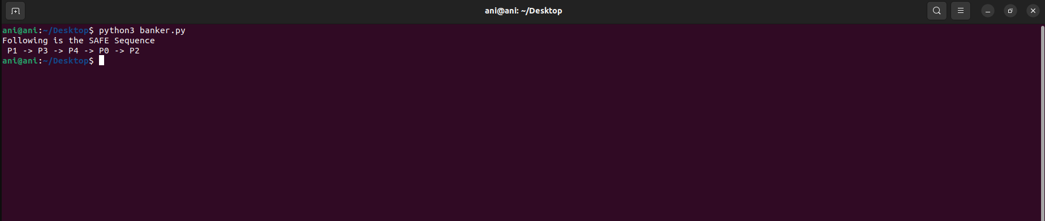

the system will skip process 0 and move to process 1. Because each process holds some resource and if the resource is not enough, the process can’t be completed. Since the system doesn’t have enough resources for process 0, it cannot complete that process. Hence the deadlock condition occurs. Once a process is completed, the system will regain the allocated resources. AS a result, there will be enough resources to allocate for upcoming processes and deadlock conditions can be avoided. Therefore, the system allocates resources in the order P1, P3, P4, P0, P2.

**RESULT: --**

We have successfully implemented Banker’s algorithm.

**Exp No.** 8 **Name:** PONNURI ANIRUDDHA

**Date**: 26/09/2022 **Reg No:** RA2112704010015

**FCFS and SJF Scheduling**

**Aim: --**

To implement FCFS (First Come First Serve) and SJF (shortest job first) in CPU scheduling.

**Procedure: --**

FCFS stands for First Come First Serve. In the FCFS scheduling algorithm, the job that arrived first in the ready queue is allocated to the CPU and then the job that came second, and so on. We can say that the ready queue acts as a FIFO (First In First Out) queue thus the arriving jobs/processes are placed at the end of the queue. FCFS is a non-preemptive scheduling algorithm as a process holds the CPU until it either terminates or performs I/O. Thus, if a longer job has been assigned to the CPU then many shorter jobs after it will have to wait. This algorithm is used in most batch operating systems.

The waiting time is the time which the second process is kept in the waiting state so that the first process is moved to the running state and executed. The burst time is the time for execution on the CPU. The turnaround time is the time in which the request for any request has been fulfilled or a job is completed. The completion time is the total time in which the process completes execution from its ready state to the executed state. The algorithms that the FCFS works are as follows:

Turn Around Time = Completion Time - Arrival Time

Waiting Time = Turnaround time - Burst Time

**Algorithm:**

* The first process arrives at the CPU.
* The completion time is calculated so that the waiting time for the next processes are calculated.
* The next processes enter/arrive at the CPU.
* While the process 1 is completing its execution the rest of the processes are kept for wait.
* The turnaround time is calculated by subtracting completion time of the process with the arrival time at the CPU.
* The total waiting time is calculated by subtracting the turnaround time and the burst time.

**Shortest Job First (SJF):**

Shortest job first (SJF) is a scheduling process that selects the waiting process with the smallest execution time to execute next. This scheduling method may or may not be preemptive. Significantly reduces the average waiting time for other processes waiting to be executed. The full form of SJF is Shortest Job First.

**Algorithm:**

* Sort all the processes according to the arrival time.
* Then select that process that has minimum arrival time and minimum Burst time.
* After completion of the process make a pool of processes that arrives afterward till the completion of the previous process and select that process among the pool which is having minimum Burst time.

**Code (FCFS)**:

*def findWaitingTime(processes, n, bt, wt, at):*

*service_time = [0] * n*

*service_time[0] = 0*

*wt[0] = 0*

*# calculating waiting time*

*for i in range(1, n):*

*# Add burst time of previous processes*

*service_time[i] = (service_time[i - 1] +*

*bt[i - 1])*

*# Find waiting time for current*

*# process = sum - at[i]*

*wt[i] = service_time[i] - at[i]*

*# If waiting time for a process is in*

*# negative that means it is already*

*# in the ready queue before CPU becomes*

*# idle so its waiting time is 0*

*if (wt[i] < 0):*

*wt[i] = 0*

*# Function to calculate turn around time*

*def findTurnAroundTime(processes, n, bt, wt, tat):*

*# Calculating turnaround time by*

*# adding bt[i] + wt[i]*

*for i in range(n):*

*tat[i] = bt[i] + wt[i]*

*# Function to calculate average waiting*

*# and turn-around times.*

*def findavgTime(processes, n, bt, at):*

*wt = [0] * n*

*tat = [0] * n*

*# Function to find waiting time*

*# of all processes*

*findWaitingTime(processes, n, bt, wt, at)*

*# Function to find turn around time for*

*# all processes*

*findTurnAroundTime(processes, n, bt, wt, tat)*

*# Display processes along with all details*

*print("Processes Burst Time Arrival Time Waiting",*

*"Time Turn-Around Time Completion Time \n")*

*total_wt = 0*

*total_tat = 0*

*for i in range(n):*

*total_wt = total_wt + wt[i]*

*total_tat = total_tat + tat[i]*

*compl_time = tat[i] + at[i]*

*print(" ", i + 1, "\t\t", bt[i], "\t\t", at[i],*

*"\t\t", wt[i], "\t\t ", tat[i], "\t\t ", compl_time)*

*print("Average waiting time = %.5f "%(total_wt /n))*

*print("\nAverage turn around time = ", total_tat / n)*

*# Driver code*

*if __name__ =="__main__":*

*# Process id's*

*processes = [1, 2, 3]*

*n = 3*

*# Burst time of all processes*

*burst_time = [5, 9, 6]*

*# Arrival time of all processes*

*arrival_time = [0, 3, 6]*

*findavgTime(processes, n, burst_time,arrival_time)*

**OUTPUT (FCFS): --**

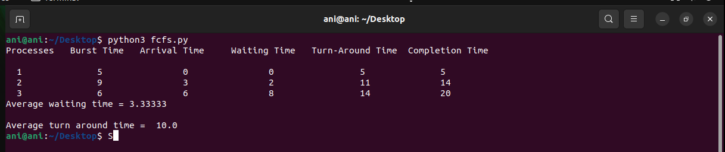

**Code (SJF): --**

*def findWaitingTime(processes, n, wt):*

*rt = [0] * n*

*# Copy the burst time into rt[]*

*for i in range(n):*

*rt[i] = processes[i][1]*

*complete = 0*

*t = 0*

*minm = 999999999*

*short = 0*

*check = False*

*# Process until all processes gets*

*# completed*

*while (complete != n):*

*# Find process with minimum remaining*

*# time among the processes that*

*# arrives till the current time`*

*for j in range(n):*

*if ((processes[j][2] <= t) and*

*(rt[j] < minm) and rt[j] > 0):*

*minm = rt[j]*

*short = j*

*check = True*

*if (check == False):*

*t += 1*

*continue*

*# Reduce remaining time by one*

*rt[short] -= 1*

*# Update minimum*

*minm = rt[short]*

*if (minm == 0):*

*minm = 999999999*

*# If a process gets completely*

*# executed*

*if (rt[short] == 0):*

*# Increment complete*

*complete += 1*

*check = False*

*# Find finish time of current*

*# process*

*fint = t + 1*

*# Calculate waiting time*

*wt[short] = (fint - proc[short][1] -*

*proc[short][2])*

*if (wt[short] < 0):*

*wt[short] = 0*

*# Increment time*

*t += 1*

*# Function to calculate turn around time*

*def findTurnAroundTime(processes, n, wt, tat):*

*# Calculating turnaround time*

*for i in range(n):*

*tat[i] = processes[i][1] + wt[i]*

*# Function to calculate average waiting*

*# and turn-around times.*

*def findavgTime(processes, n):*

*wt = [0] * n*

*tat = [0] * n*

*# Function to find waiting time*

*# of all processes*

*findWaitingTime(processes, n, wt)*

*# Function to find turn around time*

*# for all processes*

*findTurnAroundTime(processes, n, wt, tat)*

*# Display processes along with all details*

*print("Processes Burst Time Waiting",*

*"Time Turn-Around Time")*

*total_wt = 0*

*total_tat = 0*

*for i in range(n):*

*total_wt = total_wt + wt[i]*

*total_tat = total_tat + tat[i]*

*print(" ", processes[i][0], " ",*

*processes[i][1], " ",*

*wt[i], " ", tat[i])*

*print("Average waiting time = %.5f "%(total_wt /n) )*

*print("Average turn around time = ", total_tat / n)*

*# Driver code*

*if __name__ =="__main__":*

*# Process id's*

*proc = [[1, 6, 1], [2, 8, 1],*

*[3, 7, 2], [4, 3, 3]]*

*n = 4*

*findavgTime(proc, n)*

**OUTPUT (SJF): --**

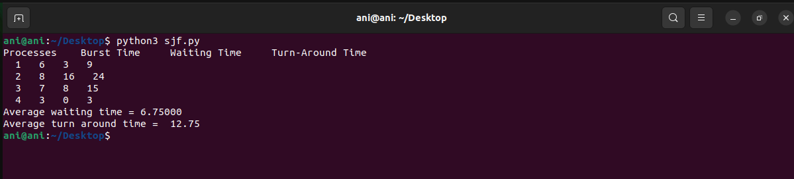

**Result:**

The code has been implemented for FCFS ( First come first serve ) type of CPU

Scheduling and SJF ( Shortest Job First ) type of CPU Scheduling.

**Exp No.** 9 **Name:** PONNURI ANIRUDDHA

**Date**:03/10/2022 **Reg No:** RA2112704010015

**Priority and Round robin scheduling**

**Aim: --**

To implement Priority Type and Round Robin type of CPU Scheduling

**Procedure: --**

**Priority CPU Scheduling**

Priority scheduling is one of the most common scheduling algorithms in batch systems. Each process is assigned a priority. Process with the highest priority is to be executed first and so on. Processes with the same priority are executed on first come first served basis. Priority can be decided based on memory requirements, time requirements or any other resource requirement.

**Round Robin CPU Scheduling**: --

Round Robin is a CPU scheduling algorithm where each process is cyclically assigned a fixed time slot. It is the preemptive version of First come First Serve CPU Scheduling algorithm. Round Robin CPU Algorithm generally focuses on Time Sharing technique. The period of time for which a process or job is allowed to run in a pre-emptive method is called time quantum. Each process or job present in the ready queue is assigned the CPU for that time quantum, if the execution of the process is completed during that time then the process will end else the process will go back to the waiting table and wait for its next turn to complete the execution.

**Code (Priority Scheduling): --**

*def findWaitingTime(processes, n, wt):*

*wt[0] = 0*

*# calculating waiting time*

*for i in range(1, n):*

*wt[i] = processes[i - 1][1] + wt[i - 1]*

*# Function to calculate turn around time*

*def findTurnAroundTime(processes, n, wt, tat):*

*# Calculating turnaround time by*

*# adding bt[i] + wt[i]*

*for i in range(n):*

*tat[i] = processes[i][1] + wt[i]*

*# Function to calculate average waiting*

*# and turn-around times.*

*def findavgTime(processes, n):*

*wt = [0] * n*

*tat = [0] * n*

*# Function to find waiting time*

*# of all processes*

*findWaitingTime(processes, n, wt)*

*# Function to find turn around time*

*# for all processes*

*findTurnAroundTime(processes, n, wt, tat)*

*# Display processes along with all details*

*print("\nProcesses Burst Time Waiting","Time Turn-Around Time")*

*total_wt = 0*

*total_tat = 0*

*for i in range(n):*

*total_wt = total_wt + wt[i]*

*total_tat = total_tat + tat[i]*

*print(" ", processes[i][0], "\t\t",*

*processes[i][1], "\t\t",*

*wt[i], "\t\t", tat[i])*

*print("\nAverage waiting time = %.5f "%(total_wt /n))*

*print("Average turn around time = ", total_tat / n)*

*def priorityScheduling(proc, n):*

*# Sort processes by priority*

*proc = sorted(proc, key = lambda proc:proc[2], reverse = True);*

*print("Order in which processes gets executed")*

*for i in proc:*

*print(i[0], end = " ")*

*findavgTime(proc, n)*

*# Driver code*

*if __name__ =="__main__":*

*# Process id's*

*proc = [[1, 10, 1],*

*[2, 5, 0],*

*[3, 8, 1]]*

*n = 3*

*priorityScheduling(proc, n)*

**OUTPUT (Priority Scheduling): --**

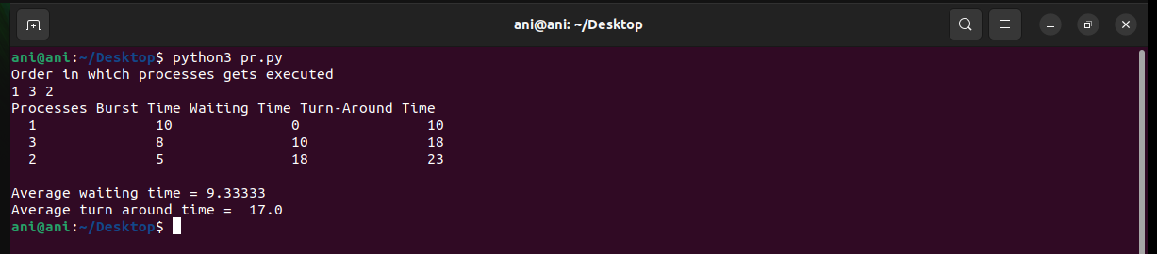

**CODE (Round Robin CPU Scheduling): --**

*def findWaitingTime(processes, n, bt, wt, quantum):*

*rem_bt = [0] * n*

*# Copy the burst time into rt[]*

*for i in range(n):*

*rem_bt[i] = bt[i]*

*t = 0 # Current time*

*# Keep traversing processes in round*

*# robin manner until all of them are*

*# not done.*

*while(1):*

*done = True*

*# Traverse all processes one by*

*# one repeatedly*

*for i in range(n):*

*# If burst time of a process is greater*

*# than 0 then only need to process further*

*if (rem_bt[i] > 0) :*

*done = False # There is a pending process*

*if (rem_bt[i] > quantum) :*

*# Increase the value of t i.e. shows*

*# how much time a process has been processed*

*t += quantum*

*# Decrease the burst_time of current*

*# process by quantum*

*rem_bt[i] -= quantum*

*# If burst time is smaller than or equal*

*# to quantum. Last cycle for this process*

*else:*

*# Increase the value of t i.e. shows*

*# how much time a process has been processed*

*t = t + rem_bt[i]*

*# Waiting time is current time minus*

*# time used by this process*

*wt[i] = t - bt[i]*

*# As the process gets fully executed*

*# make its remaining burst time = 0*

*rem_bt[i] = 0*

*# If all processes are done*

*if (done == True):*

*break*

*# Function to calculate turn around time*

*def findTurnAroundTime(processes, n, bt, wt, tat):*

*# Calculating turnaround time*

*for i in range(n):*

*tat[i] = bt[i] + wt[i]*

*# Function to calculate average waiting*

*# and turn-around times.*

*def findavgTime(processes, n, bt, quantum):*

*wt = [0] * n*

*tat = [0] * n*

*# Function to find waiting time*

*# of all processes*

*findWaitingTime(processes, n, bt, wt, quantum)*

*# Function to find turn around time*

*# for all processes*

*findTurnAroundTime(processes, n, bt, wt, tat)*

*# Display processes along with all details*

*print("Processes Burst Time Waiting","Time Turn-Around Time")*

*total_wt = 0*

*total_tat = 0*

*for i in range(n):*

*total_wt = total_wt + wt[i]*

*total_tat = total_tat + tat[i]*

*print(" ", i + 1, "\t\t", bt[i],*

*"\t\t", wt[i], "\t\t", tat[i])*

*print("\nAverage waiting time = %.5f "%(total_wt /n) )*

*print("Average turn around time = %.5f "% (total_tat / n))*

*# Driver code*

*if __name__ =="__main__":*

*# Process id's*

*proc = [1, 2, 3]*

*n = 3*

*# Burst time of all processes*

*burst_time = [10, 5, 8]*

*# Time quantum*

*quantum = 2;*

*findavgTime(proc, n, burst_time, quantum)*

**OUTPUT (Round Robin CPU Scheduling): --**

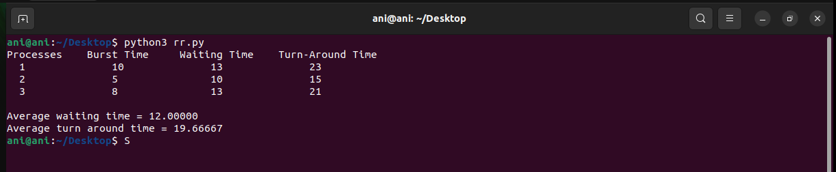

**RESULT: --**

The priority based and round robin based types of CPU scheduling algorithms are implemented and tested.

**Exp No.** 10 **Name:** PONNURI ANIRUDDHA

**Date**: 12/10/2022 **Reg No:** RA2112704010015

FIFO Page Replacement Algorithm

**Aim: --**

To implement FIFO page replacement algorithm.

**Procedure: --**

**Page Replacement algorithm:**

In operating systems that use paging for memory management, page replacement algorithms are needed to decide which page needs to be replaced when a new page comes in. Whenever a new page is referred and not present in memory, page fault occurs and the Operating System replaces one of the existing pages with a newly needed page. Different page replacement algorithms suggest different ways to decide which page to replace. The target for all algorithms is to reduce the number of page faults.

**CODE (FCFS): --**

*from queue import Queue*

*def pageFaults(pages, n, capacity):*

*# To represent set of current pages.*

*# We use an unordered_set so that we quickly check if a page is present in set or not*

*s = set()*

*# To store the pages in FIFO manner*

*indexes = Queue()*

*# Start from initial page*

*page_faults = 0*

*for i in range(n):*

*# Check if the set can hold more pages*

*if (len(s) < capacity):*

*# Insert it into set if not present already which represents page fault*

*if (pages[i] not in s):*

*s.add(pages[i])*

*# increment page fault*

*page_faults += 1*

*# Push the current page into the queue*

*indexes.put(pages[i])*

*# If the set is full then need to perform FIFO*

*# i.e. remove the first page of the queue from*

*# set and queue both and insert the current page*

*else:*

*# Check if current page is not*

*# already present in the set*

*if (pages[i] not in s):*

*# Pop the first page from the queue*

*val = indexes.queue[0]*

*indexes.get()*

*# Remove the indexes page*

*s.remove(val)*

*# insert the current page*

*s.add(pages[i])*

*# push the current page into*

*# the queue*

*indexes.put(pages[i])*

*# Increment page faults*

*page_faults += 1*

*return page_faults*

*# Driver code*

*if __name__ == '__main__':*

*pages = [7, 0, 1, 2, 0, 3, 0,*

*4, 2, 3, 0, 3, 2]*

*n = len(pages)*

*capacity = int(input("Enter number of page frames:--"))*

*print("Number of page faults: --",pageFaults(pages, n, capacity))*

**OUTPUT (FCFS): --**

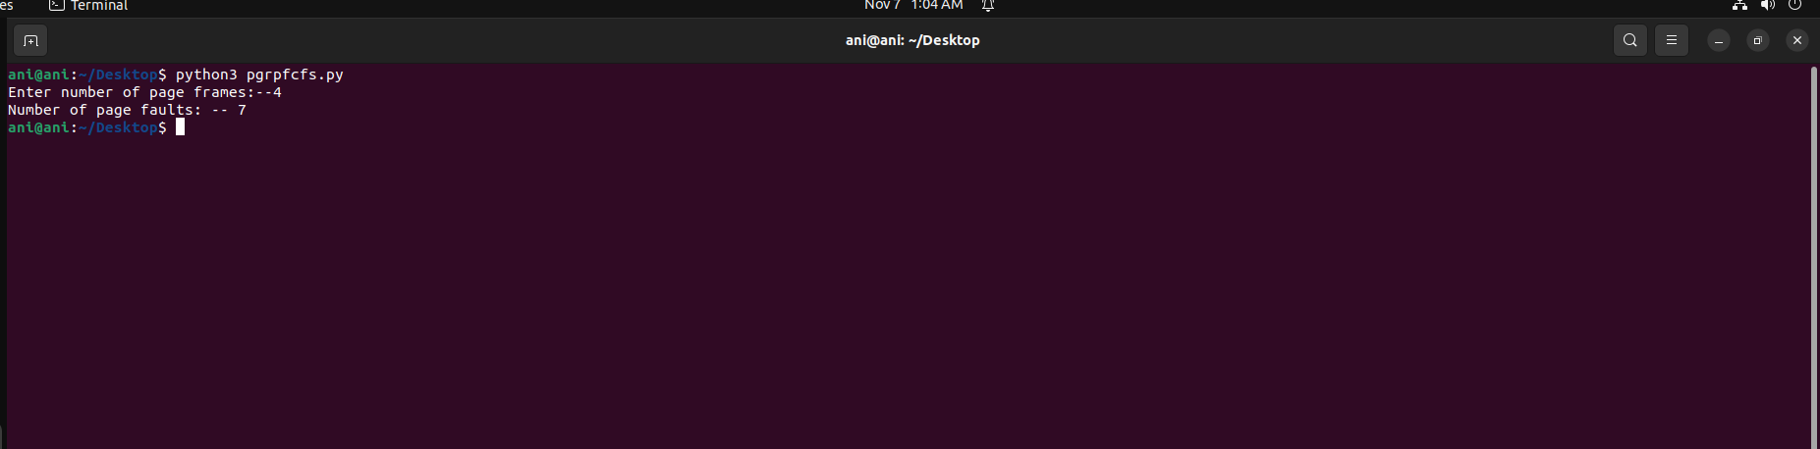

**RESULT: --**

The FIFO Page Replacement Algorithm is successfully implemented using python program.

**Exp No.** 11 **Name:** PONNURI ANIRUDDHA

**Date**: 18/10/2022 **Reg No:** RA2112704010015

**LRU and LFU Page Replacement Algorithm**

**Aim: --**

To implement LRU and LFU Page Replacement Algorithm

**Procedure: --**

**LRU (Least Recently Used) Page Replacement:**

The LRU stands for the Least Recently Used. It keeps track of page usage in the memory over a short period of time. It works on the concept that pages that have been highly used in the past are likely to be significantly used again in the future. It removes the page that has not been utilized in the memory for the longest time. LRU is the most widely used algorithm because it provides fewer page faults than the other methods.

**LFU (Least Frequently Used) Page Replacement:**

In this, it is using the concept of paging for memory management, a page replacement algorithm is needed to decide which page needs to be replaced when the new page comes in. Whenever a new page is referred to and is not present in memory, the page fault occurs and the Operating System replaces one of the existing pages with a newly needed page. LFU is one such page replacement policy in which the least frequently used pages are replaced. If the frequency of pages is the same, then the page that has arrived first is replaced first.

**Code (LRU):** --

*capacity = int(input(‘Enter number of page frames :-- ‘)*

*processList = [ 7, 0, 1, 2, 0, 3, 0,4, 2, 3, 0, 3, 2]*

*# List of current pages in Main Memory*

*s = []*

*pageFaults = 0*

*for i in processList:*

*# If i is not present in currentPages list*

*if i not in s:*

*# Check if the list can hold equal pages*

*if(len(s) == capacity):*

*s.remove(s[0])*

*s.append(i)*

*else:*

*s.append(i)*

*# Increment Page faults*

*pageFaults +=1*

*# If page is already there in*

*# currentPages i.e in Main*

*else:*

*# Remove previous index of current page*

*s.remove(i)*

*# Now append it, at last index*

*s.append(i)*

*print("No of page faults :-- ",pageFaults)*

**OUTPUT (LRU): --**

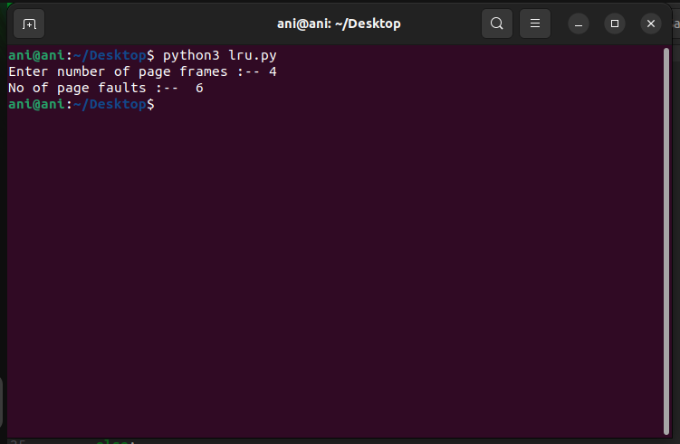

**Code (LFU): --**

*#include <bits/stdc++.h>*

*using namespace std;*

*int pageFaults(int n, int c, int pages[])*

*{*

*// Initialise count to 0*

*int count = 0;*

*vector<int> v;*

*// To store frequency of pages*

*unordered_map<int, int> mp;*

*int i;*

*for (i = 0; i <= n - 1; i++) {*

*// Find if element is present in memory or not*

*auto it = find(v.begin(), v.end(), pages[i]);*

*// If element is not present*

*if (it == v.end()) {*

*// If memory is full*

*if (v.size() == c) {*

*// Decrease the frequency*

*mp[v[0]]--;*

*// Remove the first element as*

*// It is least frequently used*

*v.erase(v.begin());*

*}*

*// Add the element at the end of memory*

*v.push_back(pages[i]);*

*// Increase its frequency*

*mp[pages[i]]++;*

*// Increment the count*

*count++;*

*}*

*else {*

*// If element is present*

*// Remove the element*

*// And add it at the end*

*// Increase its frequency*

*mp[pages[i]]++;*

*v.erase(it);*

*v.push_back(pages[i]);*

*}*

*// Compare frequency with other pages*

*// starting from the 2nd last page*

*int k = v.size() - 2;*

*// Sort the pages based on their frequency*

*// And time at which they arrive*

*// if frequency is same*

*// then, the page arriving first must be placed first*

*while (mp[v[k]] > mp[v[k + 1]] && k > -1) {*

*swap(v[k + 1], v[k]);*

*k--;*

*}*

*}*

*return count;*

*}*

*int main()*

*{*

*int pages[] = { 1, 2, 3, 4, 2, 1, 5 };*

*int n = 7, c = 3;*

*cout << "Page Faults = " << pageFaults(n, c, pages)<< endl;*

*cout << "Page Hits = " << n - pageFaults(n, c, pages);*

*return 0;*

*}*

**OUTPUT (LFU): --**

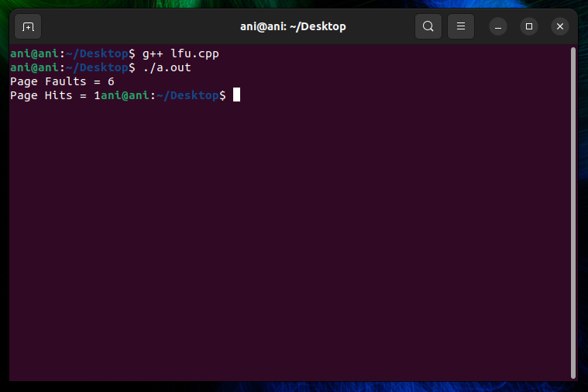

**RESULT: --**

Successfully implemented LRU and LFU page replacement algorithm in python

**Exp No.** 12 **Name:** PONNURI ANIRUDDHA

**Date**: 18/10/2022 **Reg No:** RA2112704010015

**Best fit and Worst fit memory management policies**

**Aim: --**

To implement Best fit and Worst fit memory management policies

**Procedure: --**

**BEST FIT MEMORY MANAGEMENT: --**

This method keeps the free/busy list in order by size – smallest to largest. In this method, the operating system first searches the whole of the memory according to the size of the given job and allocates it to the closest-fitting free partition in the memory, making it able to use memory efficiently. Here the jobs are in the order from smallest job to largest job.

Advantages of Best-Fit Allocation:   
Memory Efficient. The operating system allocates the job minimum possible space in the memory, making memory management very efficient. To save memory from getting wasted, it is the best method.

Best-Fit Allocation Benefits:   
It is a Slow Process. Checking the whole memory for each job makes the working of the operating system very slow. It takes a lot of time to complete the work.

**WORST FIT MEMORY MANAGEMENT: --**

In this allocation method, the process scans the entire memory, looking for the biggest hole or partition, and then it is allocated to that hole or partition. In order to find the biggest hole, the method must go over the entire memory, which takes time.

Worst-Fit Allocation Benefits

There will be significant internal fragmentation because this process selects the greatest hole or fragment. This internal fragmentation will now be sufficiently large to allow for the placement of additional smaller processes in the unused partition.

Worst-Fit Allocation Drawbacks:

It is a slow procedure since it first navigates across every memory partition before choosing the largest one, which takes a long time.

**CODE (BEST FIT): --**

*def bestFit(blockSize, m, processSize, n):*

*# Stores block id of the block allocated to a process*

*allocation = [-1] * n*

*for i in range(n):*

*# Find the best fit block for current process*

*bestIdx = -1*

*for j in range(m):*

*if blockSize[j] >= processSize[i]:*

*if bestIdx == -1:*

*bestIdx = j*

*elif blockSize[bestIdx] > blockSize[j]:*

*bestIdx = j*

*# If we could find a block for*

*# current process*

*if bestIdx != -1:*

*# allocate block j to p[i] process*

*allocation[i] = bestIdx*

*# Reduce available memory in this block.*

*blockSize[bestIdx] -= processSize[i]*

*print("Process No. Process Size Block no.")*

*for i in range(n):*

*print(i + 1, " ", processSize[i],end = " ")*

*if allocation[i] != -1:*

*print(allocation[i] + 1)*

*else:*

*print("Not Allocated")*

*# Driver code*

*if __name__ == '__main__':*

*blockSize = []*

*processSize = []*

*m = int(input("Enter Number of memory holes:--"))*

*n = int(input("Enter Number of Processess:--"))*

*for i in range(m):*

*x=int(input("Enter memory hole size:--- "))*

*blockSize.append(x)*

*for i in range(n):*

*x=int(input("Enter Process size:--- "))*

*processSize.append(x)*

*bestFit(blockSize, m, processSize, n)*

**OUTPUT (BEST FIT): --**

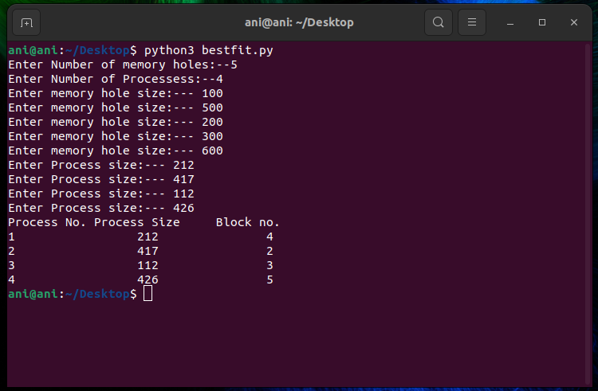

**CODE (WORST FIT): --**

*def worstFit(blockSize, m, processSize, n):*

*# Stores block id of the block allocated to a process*

*# Initially no block is assigned*

*# to any process*

*allocation = [-1] * n*

*# pick each process and find suitable blocks*

*# according to its size ad assign to it*

*for i in range(n):*

*# Find the best fit block for*

*# current process*

*wstIdx = -1*

*for j in range(m):*

*if blockSize[j] >= processSize[i]:*

*if wstIdx == -1:*

*wstIdx = j*

*elif blockSize[wstIdx] < blockSize[j]:*

*wstIdx = j*

*# If we could find a block for*

*# current process*

*if wstIdx != -1:*

*# allocate block j to p[i] process*

*allocation[i] = wstIdx*

*# Reduce available memory in this block.*

*blockSize[wstIdx] -= processSize[i]*

*print("Process No. Process Size Block no.")*

*for i in range(n):*

*print(i + 1, " ",*

*processSize[i], end=" ")*

*if allocation[i] != -1:*

*print(allocation[i] + 1)*

*else:*

*print("Not Allocated")*

*# Driver code*

*if __name__ == '__main__':*

*blockSize = []*

*processSize = []*

*m = int(input("Enter Number of memory holes:--"))*

*n = int(input("Enter Number of Processess:--"))*

*for i in range(m):*

*x = int(input("Enter memory hole size:--- "))*

*blockSize.append(x)*

*for i in range(n):*

*x = int(input("Enter Process size:--- "))*

*processSize.append(x)*

*worstFit(blockSize, m, processSize, n)*

**OUTPUT (WORST FIT): --**

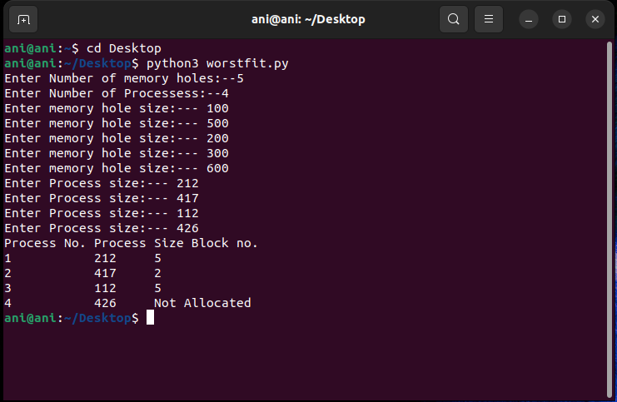

**RESULT: --**

The best fit and worst fit memory management policies are implemented using python programming.

**Exp No.** 13 **Name:** PONNURI ANIRUDDHA

**Date**: 26/10/2022 **Reg No:** RA2112704010015

**Disk Scheduling algorithm**

**Aim: --**

To implement Disk Scheduling algorithm

**Procedure: --**

Disk scheduling is done by operating systems to schedule I/O requests arriving for the disk. Disk scheduling is also known as I/O scheduling.

Disk scheduling is important because: 

* Multiple I/O requests may arrive by different processes and only one I/O request can be served at a time by the disk controller. Thus other I/O requests need to wait in the waiting queue and need to be scheduled.
* Two or more request may be far from each other so can result in greater disk arm movement.
* Hard drives are one of the slowest parts of the computer system and thus need to be accessed in an efficient manner.

There are many Disk Scheduling Algorithms but before discussing them let’s have a quick look at some of the important terms: 

* Seek Time: Seek time is the time taken to locate the disk arm to a specified track where the data is to be read or write. So the disk scheduling algorithm that gives minimum average seek time is better.
* Rotational Latency: Rotational Latency is the time taken by the desired sector of disk to rotate into a position so that it can access the read/write heads. So the disk scheduling algorithm that gives minimum rotational latency is better.
* Transfer Time: Transfer time is the time to transfer the data. It depends on the rotating speed of the disk and number of bytes to be transferred.
* Disk Access Time: Disk Access Time is:

Disk Access Time = Seek Time + Rotational Latency + Transfer Time

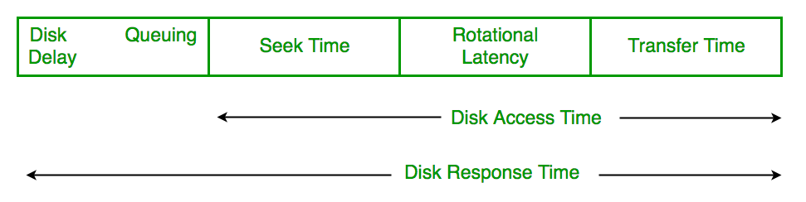

* Disk Response Time: Response Time is the average of time spent by a request waiting to perform its I/O operation. *Average Response time*is the response time of the all requests. *Variance Response Time*is measure of how individual request are serviced with respect to average response time. So the disk scheduling algorithm that gives minimum variance response time is better.

**Disk Scheduling Algorithms**

**FCFS:**

FCFS is the simplest of all the Disk Scheduling Algorithms. In FCFS, the requests are addressed in the order they arrive in the disk queue. Let us understand this with the help of an example.

**Algorithm:**

* Let Request array represents an array storing indexes of tracks that have been requested in ascending order of their time of arrival. ‘head’ is the position of disk head.
* Let us one by one take the tracks in default order and calculate the absolute distance of the track from the head.
* Increment the total seek count with this distance.
* Currently serviced track position now becomes the new head position.
* Go to step 2 until all tracks in request array have not been serviced.

Example:

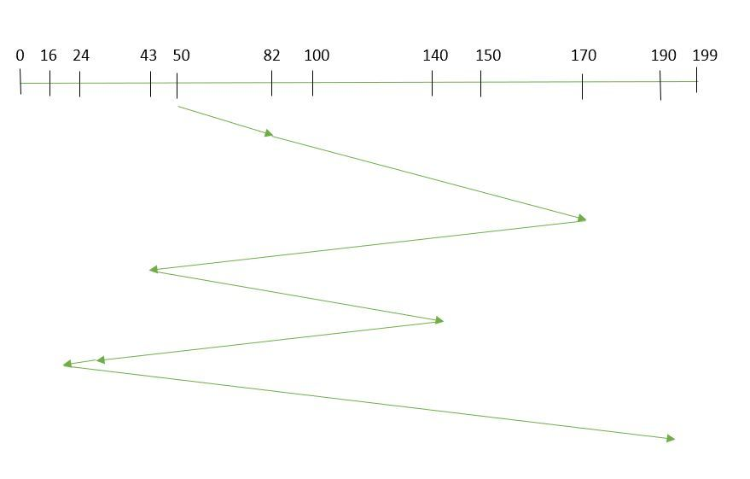Suppose the order of request is- (82,170,43,140,24,16,190)  
And current position of Read/Write head is: 50

**Shortest Seek Time First:**

In SSTF (Shortest Seek Time First), requests having shortest seek time are executed first. So, the seek time of every request is calculated in advance in the queue and then they are scheduled according to their calculated seek time. As a result, the request near the disk arm will get executed first. SSTF is certainly an improvement over FCFS as it decreases the average response time and increases the throughput of system. Let us understand this with the help of an example.

Example:

Suppose the order of request is- (176, 79, 34, 60, 92, 11, 41, 114)  
And current position of Read/Write head is : 50 

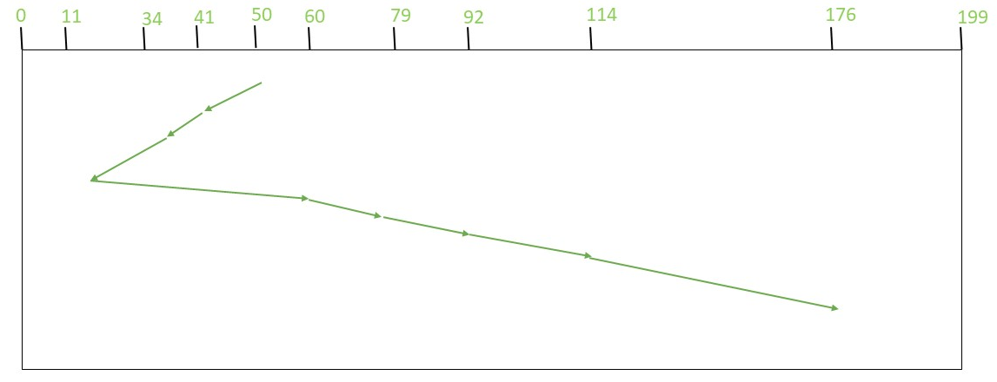

So, total seek time:

= (50-41)+(41-34)+(34-11)+(60-11)+(79-60)+(92-79)+(114-92)

+(176-114)

= 204

**CSCAN:**

In SCAN algorithm, the disk arm again scans the path that has been scanned, after reversing its direction. So, it may be possible that too many requests are waiting at the other end or there may be zero or few requests pending at the scanned area.

These situations are avoided in CSCANalgorithm in which the disk arm instead of reversing its direction goes to the other end of the disk and starts servicing the requests from there. So, the disk arm moves in a circular fashion and this algorithm is also similar to SCAN algorithm and hence it is known as C-SCAN (Circulars SCAN).

**Example:**

Suppose the requests to be addressed are- 176, 79, 34, 60, 92, 11, 41, 114. And the Read/Write arm is at 50, and it is also given that the disk arm should move “towards the larger value”.

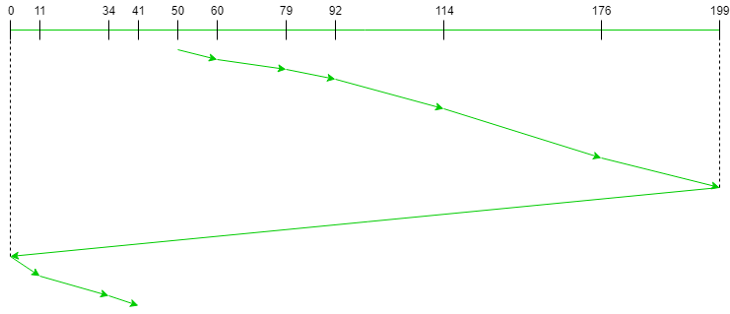

Therefore, the total seek count is calculated as: 

= (60-50)+(79-60)+(92-79) + (114-92)+(176-114)+(199-176)+(199-0)

+(11-0)+(34-11)+(41-34)

= 389

**CLOOK**

 As LOOK is similar to SCAN algorithm, in similar way, CLOOK is similar to CSCAN disk scheduling algorithm. In CLOOK, the disk arm in spite of going to the end goes only to the last request to be serviced in front of the head and then from there goes to the other end’s last request. Thus, it also prevents the extra delay which occurred due to unnecessary traversal to the end of the disk.

Example:

Suppose the requests to be addressed are- 176, 79, 34, 60, 92, 11, 41, 114. And the Read/Write arm is at 50 and it is also given that the disk arm should move “towards the larger value”

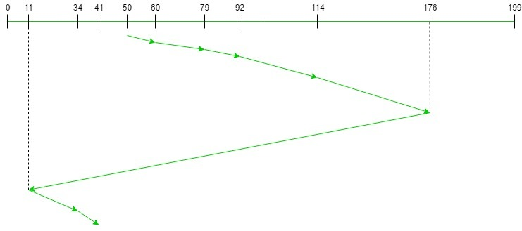

Therefore, the total seek count

= (60 – 50) + (79 – 60) + (92 – 79) + (114 – 92) + (176 – 114)

+ (176 – 11) + (34 – 11) + (41 – 34)

= 321

**CODE (FCFS): --**

*def FCFS(arr, head):*

*seek_count = 0;*

*distance, cur_track = 0, 0;*

*for i in range(size):*

*cur_track = arr[i]*

*# calculate absolute distance*

*distance = abs(cur_track - head)*

*# increase the total count*

*seek_count += distance*

*# accessed track is now new head*

*head = cur_track*

*print("Total number of seek operations = ",seek_count)*

*# Seek sequence would be the same*

*# as request array sequence*

*print("Seek Sequence is");*

*for i in range(size):*

*print(arr[i]);*

*# Driver code*

*if __name__ == '__main__':*

*# request array*

*arr = []*

*size = int(input("Enter size of request array:-- "))*

*for i in range(size):*

*x = int(input(f'Enter positon {i+1}:--'))*

*arr.append(x)*

*head = int(input("Enter Current position of head :-- "))*

*FCFS(arr, head);*

**OUTPUT (FCFS): --**

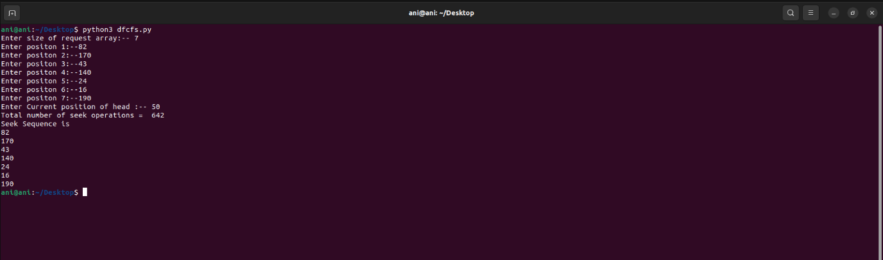

**CODE (SSTF): --**

*def calculateDifference(queue, head, diff):*

*for i in range(len(diff)):*

*diff[i][0] = abs(queue[i] - head)*

*# find unaccessed track which is*

*# at minimum distance from head*

*def findMin(diff):*

*index = -1*

*minimum = 999999999*

*for i in range(len(diff)):*

*if (not diff[i][1] and*

*minimum > diff[i][0]):*

*minimum = diff[i][0]*

*index = i*

*return index*

*def shortestSeekTimeFirst(request, head):*

*if (len(request) == 0):*

*return*

*l = len(request)*

*diff = [0] * l*

*# initialize array*

*for i in range(l):*

*diff[i] = [0, 0]*

*# count total number of seek operation*

*seek_count = 0*

*# stores sequence in which disk*

*# access is done*

*seek_sequence = [0] * (l + 1)*

*for i in range(l):*

*seek_sequence[i] = head*

*calculateDifference(request, head, diff)*

*index = findMin(diff)*

*diff[index][1] = True*

*# increase the total count*

*seek_count += diff[index][0]*

*# accessed track is now new head*

*head = request[index]*

*# for last accessed track*

*seek_sequence[len(seek_sequence) - 1] = head*

*print("Total number of seek operations =",*

*seek_count)*

*print("Seek Sequence is")*

*# print the sequence*

*for i in range(l + 1):*

*print(seek_sequence[i])*

*# Driver code*

*if __name__ =="__main__":*

*# request array*

*arr = []*

*size = int(input("Enter size of request array:-- "))*

*for i in range(size):*

*x = int(input(f'Enter positon {i+1}:--'))*

*arr.append(x)*

*head = int(input("Enter Current position of head :-- "))*

*shortestSeekTimeFirst(arr,head)*

**OUTPUT (SSTF): --**

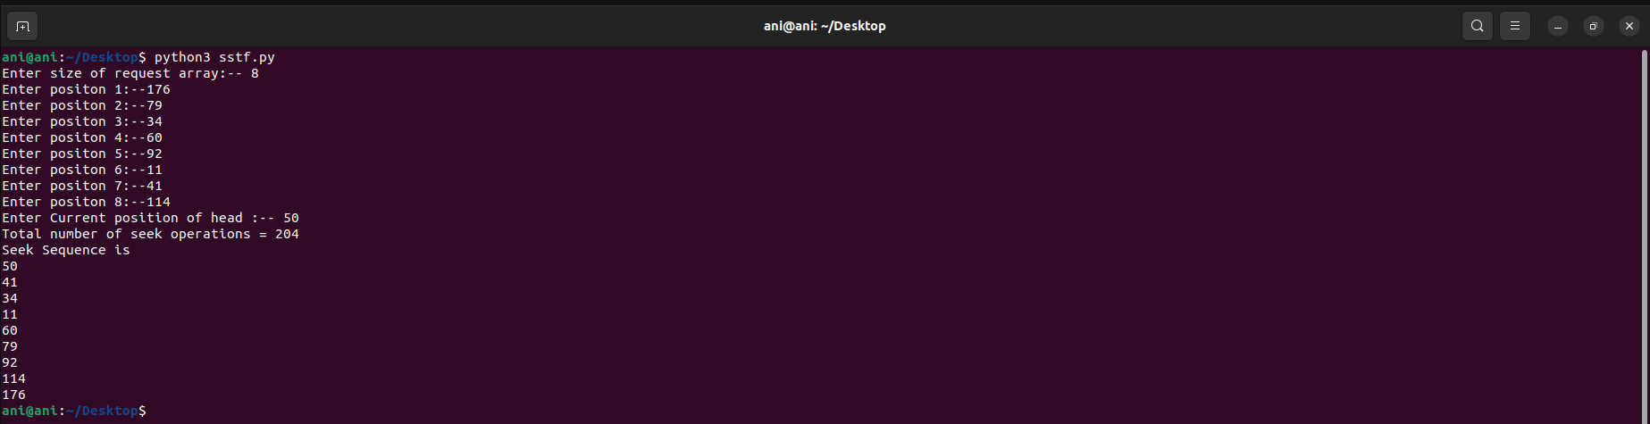

**CODE(CSCAN): --**

*disk_size = 200*

*def CSCAN(arr, head):*

*seek_count = 0*

*distance = 0*

*cur_track = 0*

*left = []*

*right = []*

*seek_sequence = []*

*left.append(0)*

*right.append(disk_size - 1)*

*for i in range(size):*

*if (arr[i] < head):*

*left.append(arr[i])*

*if (arr[i] > head):*

*right.append(arr[i])*

*# Sorting left and right vectors*

*left.sort()*

*right.sort()*

*# First service the requests*

*# on the right side of the*

*# head.*

*for i in range(len(right)):*

*cur_track = right[i]*

*# Appending current track*

*# to seek sequence*

*seek_sequence.append(cur_track)*

*# Calculate absolute distance*

*distance = abs(cur_track - head)*

*# Increase the total count*

*seek_count += distance*

*# Accessed track is now new head*

*head = cur_track*

*# Once reached the right end*

*# jump to the beggining.*

*head = 0*

*# adding seek count for head returning from 199 to 0*

*seek_count += (disk_size - 1)*

*# Now service the requests again*

*# which are left.*

*for i in range(len(left)):*

*cur_track = left[i]*

*# Appending current track*

*# to seek sequence*

*seek_sequence.append(cur_track)*

*# Calculate absolute distance*

*distance = abs(cur_track - head)*

*# Increase the total count*

*seek_count += distance*

*# Accessed track is now the new head*

*head = cur_track*

*print("Total number of seek operations =",seek_count)*

*print("Seek Sequence is")*

*print(*seek_sequence, sep="\n")*

*# Driver code*

*if __name__ =="__main__":*

*# request array*

*arr = []*

*size = int(input("Enter size of request array:-- "))*

*for i in range(size):*

*x = int(input(f'Enter positon {i+1}:--'))*

*arr.append(x)*

*head = int(input("Enter Current position of head :-- "))*

*CSCAN(arr,head)*

**OUTPUT (CSCAN): --**

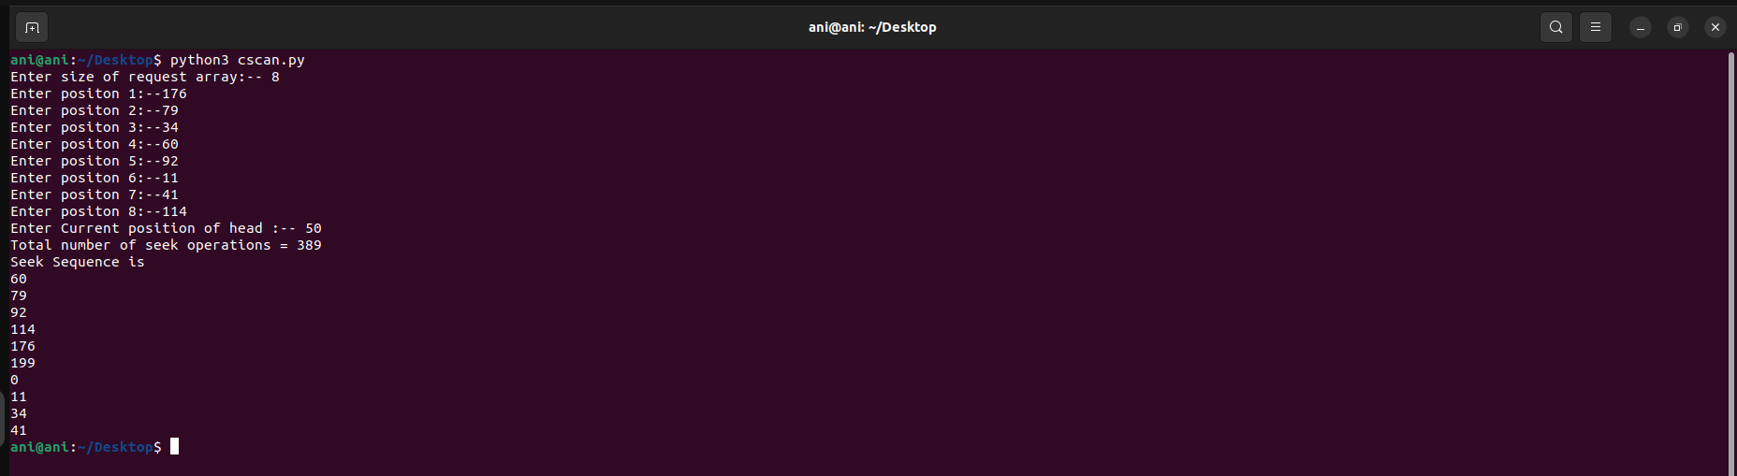

**CODE (CLOOK): --**

*disk_size = 200*

*def CLOOK(arr, head):*

*seek_count = 0*

*distance = 0*

*cur_track = 0*

*left = []*

*right = []*

*seek_sequence = []*

*for i in range(size):*

*if (arr[i] < head):*

*left.append(arr[i])*

*if (arr[i] > head):*

*right.append(arr[i])*

*# Sorting left and right vectors*

*left.sort()*

*right.sort()*

*# First service the requests*

*# on the right side of the*

*# head*

*for i in range(len(right)):*

*cur_track = right[i]*

*# Appending current track*

*# seek sequence*

*seek_sequence.append(cur_track)*

*# Calculate absolute distance*

*distance = abs(cur_track - head)*

*# Increase the total count*

*seek_count += distance*

*# Accessed track is now new head*

*head = cur_track*

*# Once reached the right end*

*# jump to the last track that*

*# is needed to be serviced in*

*# left direction*

*seek_count += abs(head - left[0])*

*head = left[0]*

*# Now service the requests again*

*# which are left*

*for i in range(len(left)):*

*cur_track = left[i]*

*# Appending current track to*

*# seek sequence*

*seek_sequence.append(cur_track)*

*# Calculate absolute distance*

*distance = abs(cur_track - head)*

*# Increase the total count*

*seek_count += distance*

*# Accessed track is now the new head*

*head = cur_track*

*print("Total number of seek operations =",*

*seek_count)*

*print("Seek Sequence is")*

*for i in range(len(seek_sequence)):*

*print(seek_sequence[i])*

*# Driver code*

*if __name__ =="__main__":*

*# request array*

*arr = []*

*size = int(input("Enter size of request array:-- "))*

*for i in range(size):*

*x = int(input(f'Enter positon {i+1}:--'))*

*arr.append(x)*

*head = int(input("Enter Current position of head :-- "))*

*CLOOK(arr,head)*

**OUTPUT (CLOOK): --**

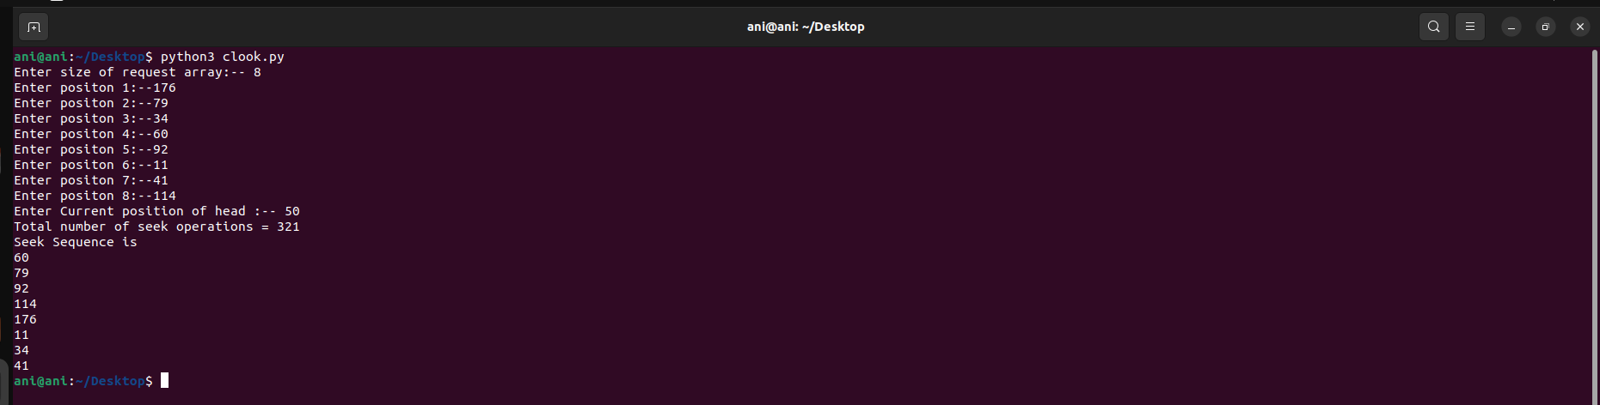

**RESULT: --**

Successfully implemented disk scheduling algorithms in python.

**Exp No.** 14 **Name:** PONNURI ANIRUDDHA

**Date**: 08/11/2022 **Reg No:** RA2112704010015

**Sequential and Indexed file Allocation**

**Aim: --**

To implement Sequential and Indexed file Allocation

**Procedure: --**

**Sequential file Allocation:**

Files are normally stored on the disks. So the main problem is how to allocate space to those files. So that disk space is utilized effectively and files can be accessed quickly. Three major strategies of allocating disc space are in wide use. Sequential, indexed and linked.

In this allocation strategy, each file occupies a set of contiguously blocks on the disk. This strategy is best suited. For sequential files, the file allocation table consists of a single entry for each file. It shows the filenames, starting block of the file and size of the file. The main problem with this strategy is, it is difficult to find the contiguous free blocks in the disk and some free blocks could happen between two files

**Indexed Allocation**

In this scheme, a special block known as the Index block contains the pointers to all the blocks occupied by a file. Each file has its own index block. The ith entry in the index block contains the disk address of the ith file block. The directory entry contains the address of the index block.

Advantages:

* This supports direct access to the blocks occupied by the file and therefore provides fast access to the file blocks.
* It overcomes the problem of external fragmentation.

Disadvantages:

* The pointer overhead for indexed allocation is greater than linked allocation.
* For very small files, say files that expand only 2-3 blocks, the indexed allocation would keep one entire block (index block) for the pointers which is inefficient in terms of memory utilization.

**Algorithm (Sequential File Allocation):**

Step 1: Start the program.

Step 2: Get the number of memory partition and their sizes.

Step 3: Get the number of processes and values of block size for each process.

Step 4: First fit algorithm searches all the entire memory block until a hole which is big enough is encountered. It allocates that memory block for the requesting process.

Step 5: Best-fit algorithm searches the memory blocks for the smallest hole which can be allocated to requesting process and allocates it.

Step 6: Worst fit algorithm searches the memory blocks for the largest hole and allocates it to the process.

Step 7: Analyses all the three memory management techniques and display the best algorithm which utilizes the memory resources effectively and efficiently.

Step 8: Stop the program.

**CODE (Sequential file Allocation)**: --

*#include <stdio.h>*

*#include <stdlib.h>*

*#include <string.h>*

*#define TOTAL_DISK_BLOCKS 32*

*#define TOTAL_DISK_INODES 8*

*#ifndef MAX*

*#define MAX 15*

*#endif*

*int blockStatus[TOTAL_DISK_BLOCKS]; // free = 0*

*int blockStart;*

*struct file_table {*

*char fileName[20];*

*int startBlock;*

*int fileSize;*

*int allotStatus;*

*};*

*struct file_table fileTable[TOTAL_DISK_BLOCKS - TOTAL_DISK_INODES];*

*int AllocateBlocks(int Size) {*

*int i = 0, count = 0, inList = 0, nextBlock = 0;*

*int allocStartBlock = TOTAL_DISK_INODES;*

*int allocEndBlock = TOTAL_DISK_BLOCKS - 1;*

*// check whether sufficient free blocks are available*

*for (i = 0; i < (TOTAL_DISK_BLOCKS - TOTAL_DISK_INODES); i++)*

*if (blockStatus[i] == 0)*

*count++;*

*if (count < Size)*

*return 1; // not enough free blocks*

*count = 0;*

*while (count < Size) {*

*nextBlock = (rand() % (allocEndBlock - allocStartBlock + 1)) + allocStartBlock;*

*for (i = nextBlock; i < (nextBlock + Size); i++) {*

*if (blockStatus[i] == 0)*

*count = count + 1;*

*else {*

*count = 0;*

*break;*

*}*

*}*

*}*

*blockStart = nextBlock;*

*for (int i = 0; i < Size; i++) {*

*blockStatus[blockStart + i] = 1;*

*}*

*if (count == Size)*

*return nextBlock; // success*

*else*

*return 1; // not successful*

*}*

*void main() {*

*int i = 0, j = 0, numFiles = 0, nextBlock = 0, ret = 1, totalFileSize = 0;*

*char s[20];*

*//-- -*

*char *header[] = {"FILE_fileName", "FILE_SIZE", "BLOCKS_OCCUPIED"};*

*printf("File allocation method: SEQUENTIAL\n");*

*printf("Total blocks: %d\n", TOTAL_DISK_BLOCKS);*

*printf("File allocation start at block: %d\n", TOTAL_DISK_INODES);*

*printf("File allocation end at block: %d\n", TOTAL_DISK_BLOCKS - 1);*

*printf("Size (kB) of each block: 1\n\n");*

*printf("Enter no of files: ");*

*scanf("%d", &numFiles);*

*//numFiles = 3;*

*for (i = 0; i < numFiles; i++) {*

*//-- -*

*printf("\nEnter the name of file #%d: ", i+1);*

*scanf("%s", fileTable[i].fileName);*

*printf("Enter the size (kB) of file #%d: ", i+1);*

*scanf("%d", &fileTable[i].fileSize);*

*//strcpy(fileTable[i].fileName, "testfile");*

*srand(1234);*

*ret = AllocateBlocks(fileTable[i].fileSize);*

*//-- -*

*if (ret == 1) {*

*exit(0);*

*} else {*

*fileTable[i].startBlock = ret;*

*}*

*}*

*//-- -*

*printf("\n%*s %*s %*s\n", -MAX, header[0], -MAX, header[1], MAX, header[2]);*

*//Seed the pseudo-random number generator used by rand() with the value seed*

*srand(1234);*

*//-- -*

*for (j = 0; j < numFiles; j++) {*

*printf("\n%*s %*d ", -MAX, fileTable[j].fileName, -MAX, fileTable[j].fileSize);*

*for(int k=0;k<fileTable[j].fileSize;k++) {*

*printf("%d%s", fileTable[j].startBlock+k, (k == fileTable[j].fileSize-1) ? "" : "-");*

*}*

*}*

*printf("\nFile allocation completed. Exiting.\n");*

*}*

**OUTPUT (Sequential file Allocation): --**

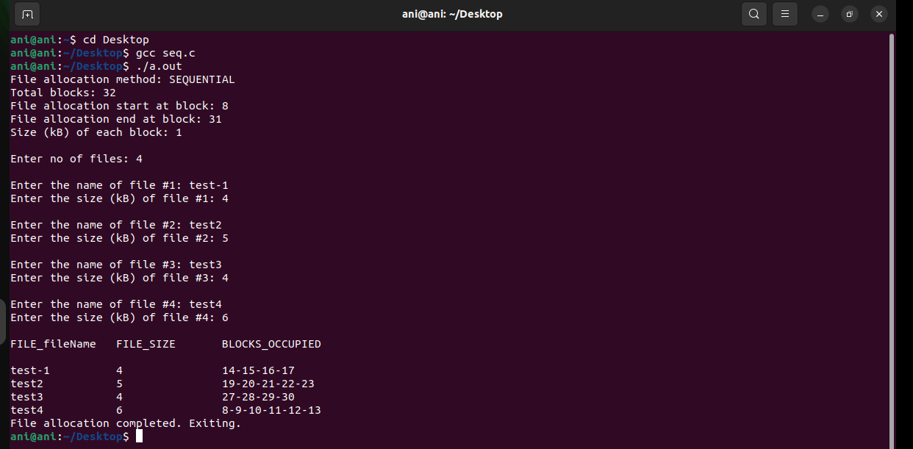

CODE (**Indexed Allocation**): --

*#include<stdio.h>*

*#include<stdlib.h>*

*void main()*

*{*

*int f[50], index[50],i, n, st, len, j, c, k, ind,count=0;*

*for(i=0;i<50;i++)*

*f[i]=0;*

*x:printf("Enter the index block: ");*

*scanf("%d",&ind);*

*if(f[ind]!=1)*

*{*

*printf("Enter no of blocks needed and no of files for the index %d on the disk : \n", ind);*

*scanf("%d",&n);*

*}*

*else*

*{*

*printf("%d index is already allocated \n",ind);*

*goto x;*

*}*

*y: count=0;*

*for(i=0;i<n;i++)*

*{*

*scanf("%d", &index[i]);*

*if(f[index[i]]==0)*

*count++;*

*}*

*if(count==n)*

*{*

*for(j=0;j<n;j++)*

*f[index[j]]=1;*

*printf("Allocated\n");*

*printf("File Indexed\n");*

*for(k=0;k<n;k++)*

*printf("%d-------->%d : %d\n",ind,index[k],f[index[k]]);*

*}*

*else*

*{*

*printf("File in the index is already allocated \n");*

*printf("Enter another file indexed");*

*goto y;*

*}*

*printf("Do you want to enter more file(Yes - 1/No - 0)");*

*scanf("%d", &c);*

*if(c==1)*

*goto x;*

*else*

*exit(0);*

*}*

**OUTPUT (Indexed Allocation): --**

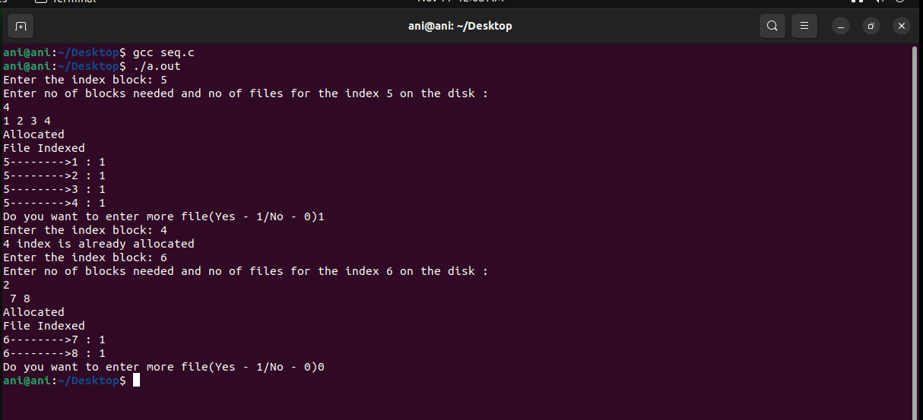

**RESULT: --**

Successfully implemented Sequential and Indexed file Allocation in c program

**Exp No.** 15 **Name:** PONNURI ANIRUDDHA

**Date**: 14/11/2022 **Reg No:** RA2112704010015

**File organization schemes for single level and two-level directory**

**Aim: --**

To implement File organization schemes for single level and two-level directory

**Procedure: --**

A File system contains thousands and millions of files, owned by several users. The directory structure organizes these files by keeping entries of all the related files. The file entries have information like file name, type, location, the mode in which the file can be accessed by other users in the system. Directory structure provides both the above-discussed features. A directory always has information about the group of related files. Whenever a user or a process request for a file, the file system search for the file’s entry in the directory and when the match is found, it obtains the file’s location from there.

**Types of Directory Structures**

1. **Single-level directory structure**

Single level directory structure has only one directory which is called the root directory. The users are not allowed to create subdirectories under the root directory. All the files created by the several users are present in the root directory only.

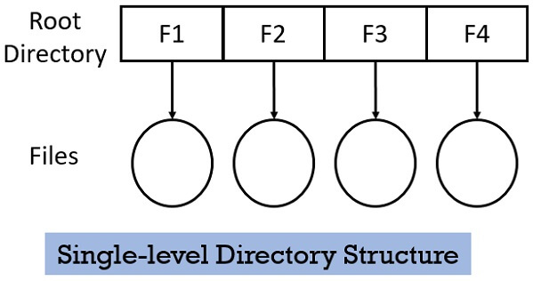

There is one drawback of Single-level directory structure, a user cannot use the same file name used by another user in the system. Even if the file with the same name is created the old file will get destroyed first and replaced by the new file having the same name.

**2. Two-level directory structure**

In Two-level directory structure, the users create directory directly inside the root directory. But once a user creates such directory, further he cannot create any subdirectory inside that directory. Observe the figure below, 4 users have created their separate directory inside the root directory. But further, no subdirectory is created by the users.

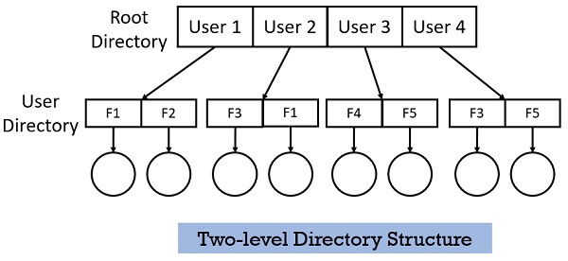

This two-level structure allows each user to keep their files separately inside their own directory. This structure allows to use the same name for the files but under different user directories.

**CODE (Single-level directory structure): --**

*#include<stdio.h>*

*#include<stdlib.h>*

*#include<string.h>*

*void main()*

*{*

*int nf=0,i=0,j=0,ch;*

*char mdname[10],fname[10][10],name[10];*

*printf("Enter the directory name:");*

*scanf("%s",mdname);*

*printf("Enter the number of files:");*

*scanf("%d",&nf);*

*do*

*{*

*printf("Enter file name to be created:");*

*scanf("%s",name);*

*for(i=0;i<nf;i++)*

*{*

*if(!strcmp(name,fname[i]))*

*break;*

*}*

*if(i==nf)*

*{*

*strcpy(fname[j++],name);*

*nf++;*

*}*

*else*

*printf("There is already %s\n",name);*

*printf("Do you want to enter another file(yes - 1 or no - 0):");*

*scanf("%d",&ch);*

*}*

*while(ch==1);*

*printf("Directory name is:%s\n",mdname);*

*printf("Files names are:");*

*for(i=0;i<j;i++)*

*printf("\n%s",fname[i]);*

*}*

**OUTPUT (Single-level directory structure): --**

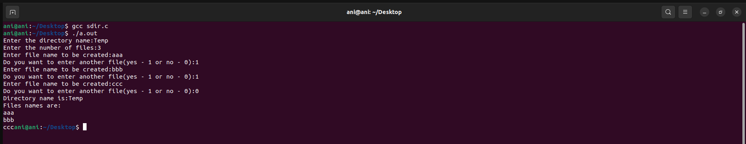

CODE: --

*#include<stdio.h>*

*#include<stdlib.h>*

*#include<string.h>*

*struct st*

*{*

*char dname[10];*

*char sdname[10][10];*

*char fname[10][10][10];*

*int ds,sds[10];*

*}dir[10];*

*void main()*

*{*

*int i,j,k,n;*

*printf("enter number of directories:");*

*scanf("%d",&n);*

*for(i=0;i<n;i++)*

*{*

*printf("enter directory %d names:",i+1);*

*scanf("%s",dir[i].dname);*

*printf("enter size of directories:");*

*scanf("%d",&dir[i].ds);*

*for(j=0;j<dir[i].ds;j++)*

*{*

*printf("enter subdirectory name and size:");*

*scanf("%s",dir[i].sdname[j]);*

*scanf("%d",&dir[i].sds[j]);*

*for(k=0;k<dir[i].sds[j];k++)*

*{*

*printf("enter file name:");*

*scanf("%s",dir[i].fname[j][k]);*

*}*

*}*

*}*

*printf("\ndirname\t\tsize\tsubdirname\tsize\tfiles");*

*printf("\n********************\n");*

*for(i=0;i<n;i++)*

*{*

*printf("%s\t\t%d",dir[i].dname,dir[i].ds);*

*for(j=0;j<dir[i].ds;j++)*

*{*

*printf("\t%s\t\t%d\t",dir[i].sdname[j],dir[i].sds[j]);*

*for(k=0;k<dir[i].sds[j];k++)*

*printf("%s\t",dir[i].fname[j][k]);*

*printf("\n\t\t");*

*}*

*printf("\n"); }*

*}*

**OUTPUT (Two-level directory structure): --**

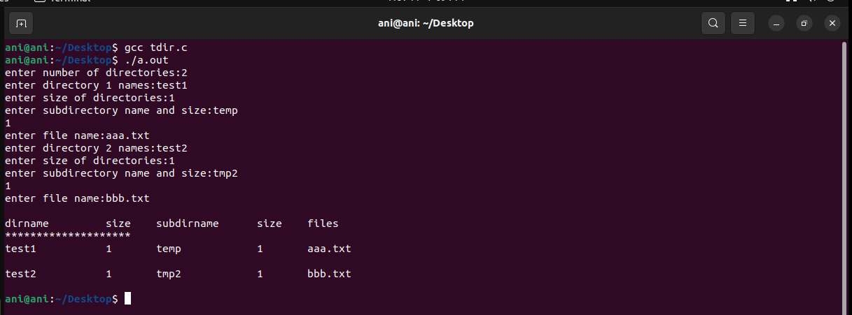

**RESULT: --**

Successfully implemented File organization schemes for single level and two level directory using c language.

|  |  |  |
| --- | --- | --- |
|  | SRM INSTITUTE OF SCIENCE AND TECHNOLOGY  SCHOOL OF COMPUTING  DEPARTMENT OF DATASCIENCE AND BUSINESS SYSTEMS  21CSC202J OPERATING SYSTEMS |  |
| MINI PROJECT REPORT  **FILE TRANSFER USING SOCKETS IN PYTHON** | | |
| Name: Ponnuri Aniruddha  Register Number: RA2112704010015  Mail ID: pp0783@srmist.edu.in  Department: MTech integrated computer science  Specialization: data Science  Semester: 3 | | |
| **Team Members**  **Name:** **Y Shabanya Kishore Registration Number: RA2112704010018** | | |

**Table Of Contents**

Abstract

Chapter 1 : Introduction and Motivation [Purpose of the problem statement (societal benefit)

Chapter 2: Review of Existing methods and their Limitations

Chapter 3 : Proposed Method with System Architecture / Flow Diagram

Chapter 4: Modules Description

Chapter 5: Implementation requirements

Chapter 5: Output Screenshots

Conclusion

References

Appendix A – Source Code

Appendix B – GitHub Profile and Link for the Project

**ABSTRACT**:

Over the last few years, there has been a drastic change in information technology. This includes the various ways in which files can be shared and stored. Linux is a relatively a popular OS which has been steadily taking over more and more market share. Easy to use, easy to develop for, and open-source, it has picked up a following of developers who want to create content for the masses. Sockets is a popular way to create a file sharing app in Linux which can be used to share files across all platform, and with the power of python we can build an interface for the app. This paper aims to combine the two, building an socket based application for Linux/Windows, offering users the power of file sharing in the palm of their hand.

**KEYWORDS:** Python, Sockets, File Transfer, Tkinter

**I. INTRODUCTION**

File sharing is the practice of distributing or providing access to digitally stored information, such as computer programs, multimedia (audio, images and video), documents, or electronic books. It may be implemented through a variety of ways.

Python is a high-level, general-purpose programming language. Its design philosophy emphasizes code readability with the use of significant indentation. Python is dynamically-typed and garbage-collected. It supports multiple programming paradigms, including structured (particularly procedural), object-oriented and functional programming. It is often described as a "batteries included" language due to its comprehensive standard library. Guido van Rossum began working on Python in the late 1980s as a successor to the ABC programming language and first released it in 1991 as Python 0.9.0.Python 2.0 was released in 2000 and introduced new features such as list comprehensions, cycle-detecting garbage collection, reference counting, and Unicode support. Python 3.0, released in 2008, was a major revision that is not completely backward-compatible with earlier versions. Python 2 was discontinued with version 2.7.18 in 2020. Python consistently ranks as one of the most popular programming languages. Python was conceived in the late 1980s[42] by Guido van Rossum at Centrum Wiskunde & Informatica (CWI) in the Netherlands as a successor to the ABC programming language, which was inspired by SETL, capable of exception handling (from the start plus new capabilities in Python 3.11) and interfacing with the Amoeba operating system. Its implementation began in December 1989. Van Rossum shouldered sole responsibility for the project, as the lead developer, until 12 July 2018, when he announced his "permanent vacation" from his responsibilities as Python's "benevolent dictator for life", a title the Python community bestowed upon him to reflect his long-term commitment as the project's chief decision-maker. In January 2019, active Python core developers elected a five-member Steering Council to lead the project.

Python provides two levels of access to the network services. At a low level, you can access the basic socket support in the underlying operating system, which allows you to implement clients and servers for both connection-oriented and connectionless protocols. Python also has libraries that provide higher-level access to specific application-level network protocols, such as FTP, HTTP, and so on. This chapter gives you an understanding on the most famous concept in Networking - Socket Programming. Sockets are the endpoints of a bidirectional communications channel. Sockets may communicate within a process, between processes on the same machine, or between processes on different continents. Sockets may be implemented over a number of different channel types: Unix domain sockets, TCP, UDP, and so on. The socket library provides specific classes for handling the common transports as

well as a generic interface for handling the rest. TCP stands for Transmission Control Protocol. It is a communication protocol that is designed for end-to-end data transmission over a network. TCP is basically the ” standard” communication protocol for data transmission over the Internet. It is a highly efficient and reliable communication protocol as it uses a three-way handshake to connect the client and the server. It is a process that requires both the client and the server to exchange synchronization (SYN) and acknowledge (ACK) packets before the data transfer takes place.

Some of the features of the TCP are as follows:

It provides end-to-end communication.

It is a connection-oriented protocol.

It provides error-checking and recovery mechanisms.

**II. Review of Existing methods and their Limitations**

At the moment, record structures are the only file structures that can be used directly with FTP. However, you don't have to use record structures. A user whose file doesn't have a record structure should be able to save and get his file from any HOST. If a user wants to send a record-structured file, he or she must send the right FTP "STRU" command (the default assumption is no record structure). A serving HOST doesn't have to accept record structures, but it must let the user know by sending the right response. The receiver can then get rid of any record structure information in the data stream. But there is no way to find bits that get lost or mixed up during data transfer. This problem might be best solved at the NCP level, where it will help the most people. But a restart procedure is available to protect the user from system failures, like when HOST, the FTP-process, or the IMP subnet fail. Only the block mode of data transfer has a defined restart procedure. It requires the person sending the data to put a special marker code with some marker information into the data stream. The marker information is only important to the sender, but it must be made up of ASCII characters that can be printed. The printable ASCII characters are defined as being codes 33. through 126. (This means that codes 0. through 31. and the characters SP and DEL are not printable ASCII characters.) The marker could be a bit count, a record count, or any other piece of information that could be used to find a data checkpoint. If the receiver of the data uses the restart procedure, it would mark the position of this marker in the receiving system and tell the user where it is.

Using the FTP restart procedure, the user can find the marker point and start the data transfer again if the system fails. Here are some examples of how the restart procedure can be used.

**III. Proposed Method with System Architecture / Flow Diagram**

The overall procedure for the TCP file transfer is presented in the figure below.

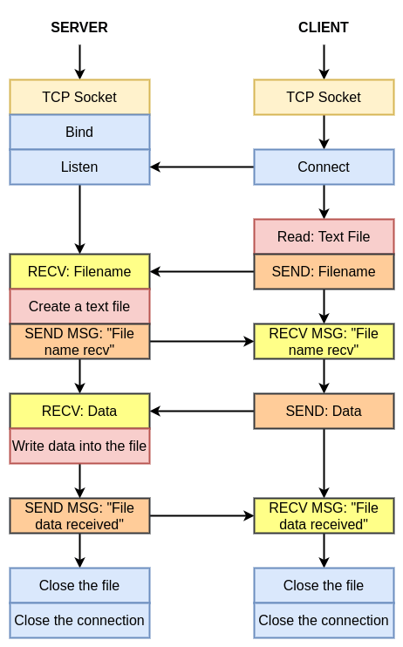

**IV. Modules Description**

**1. Tkinter (GUI):**

The tkinter package (“Tk interface”) is the standard Python interface to the Tcl/Tk GUI toolkit. Both Tk and tkinter are available on most Unix platforms, including macOS, as well as on Windows systems.

Running python -m tkinter from the command line should open a window demonstrating a simple Tk interface, letting you know that tkinter is properly installed on your system, and also showing what version of Tcl/Tk is installed, so you can read the Tcl/Tk documentation specific to that version.

Tkinter supports a range of Tcl/Tk versions, built either with or without thread support. The official Python binary release bundles Tcl/Tk 8.6 threaded. See the source code for the _tkinter module for more information about supported versions.

Tkinter is not a thin wrapper, but adds a fair amount of its own logic to make the experience more pythonic. This documentation will concentrate on these additions and changes, and refer to the official Tcl/Tk documentation for details that are unchanged.

**2. OS:**

This module provides a portable way of using operating system dependent functionality. If you just want to read or write a file see open(), if you want to manipulate paths, see the os.path module, and if you want to read all the lines in all the files on the command line see the fileinput module. For creating temporary files and directories see the tempfile module, and for high-level file and directory handling see the shutil module.

Notes on the availability of these functions:

The design of all built-in operating system dependent modules of Python is such that as long as the same functionality is available, it uses the same interface; for example, the function os.stat(path) returns stat information about path in the same format (which happens to have originated with the POSIX interface).

Extensions peculiar to a particular operating system are also available through the os module, but using them is of course a threat to portability.

All functions accepting path or file names accept both bytes and string objects, and result in an object of the same type, if a path or file name is returned.

On VxWorks, os.popen, os.fork, os.execv and os.spawn*p* are not supported.

On WebAssembly platforms wasm32-emscripten and wasm32-wasi, large parts of the os module are not available or behave differently. API related to processes (e.g. fork(), execve()), signals (e.g. kill(), wait()), and resources (e.g. nice()) are not available. Others like getuid() and getpid() are emulated or stubs.

**3. Sockets:**

This module does not work or is not available on WebAssembly platforms wasm32-emscripten and wasm32-wasi. See WebAssembly platforms for more information.

The Python interface is a straightforward transliteration of the Unix system call and library interface for sockets to Python’s object-oriented style: the socket() function returns a *socket object* whose methods implement the various socket system calls. Parameter types are somewhat higher-level than in the C interface: as with read() and write() operations on Python files, buffer allocation on receive operations is automatic, and buffer length is implicit on send operations.

**V. IMPLEMENTATION REQUIREMENTS**

Both sender and receiver should on same local network i.e. same Wi-Fi.

If you want to run the code in Terminal.

First run the main.py file in send mode

Then run the reciever.py or main.py file in receiver mode

both should be running simultaneously

In file transfer type the filename will be "received" with file extension from sender file

After file is transfer successfully then program i.e receiver.py will exit successfully

**VI. Output Screenshots**

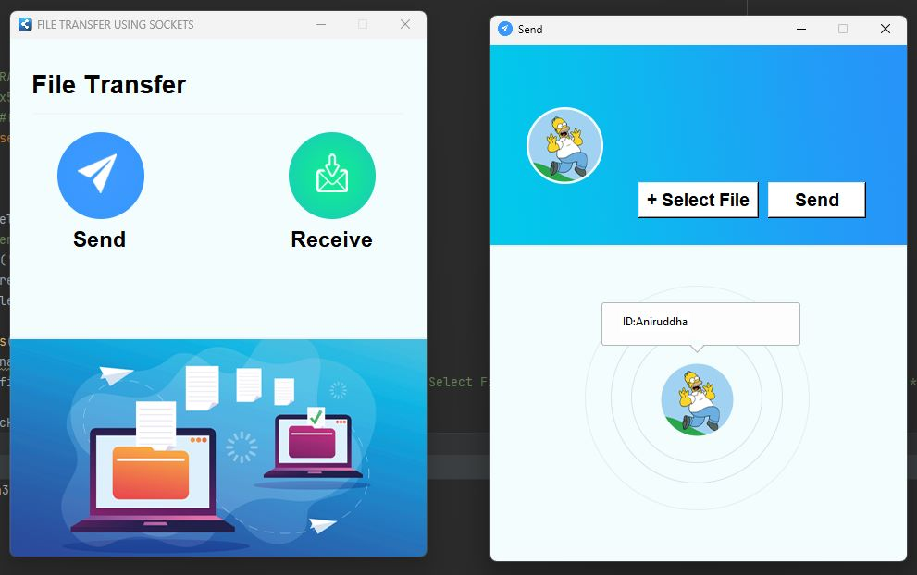

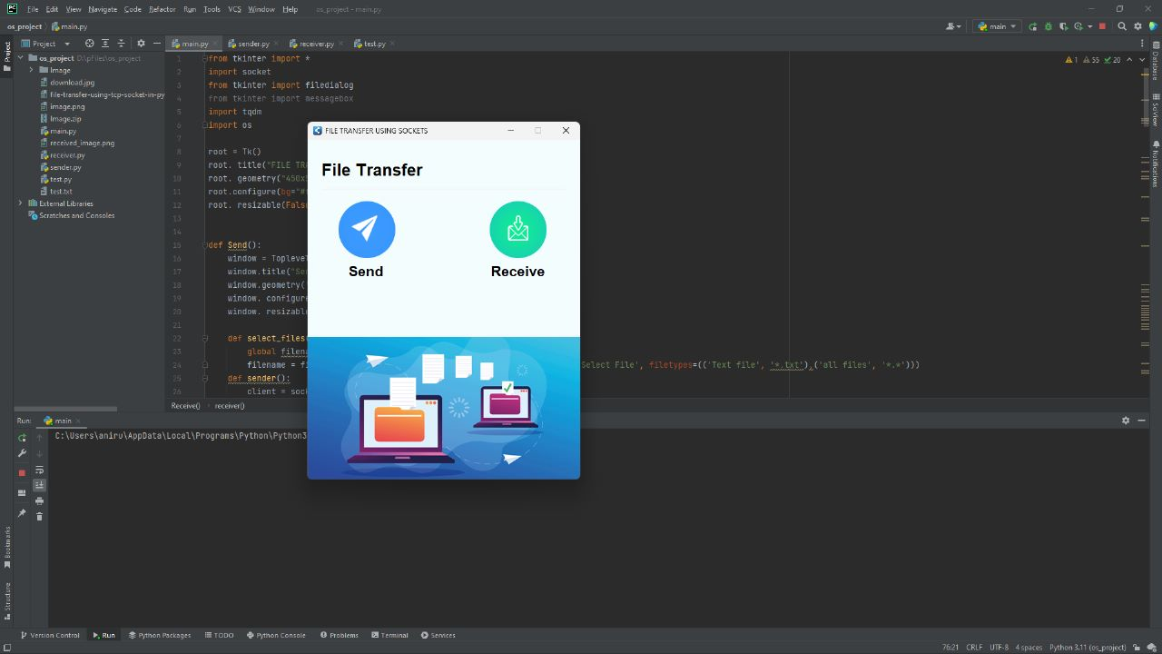

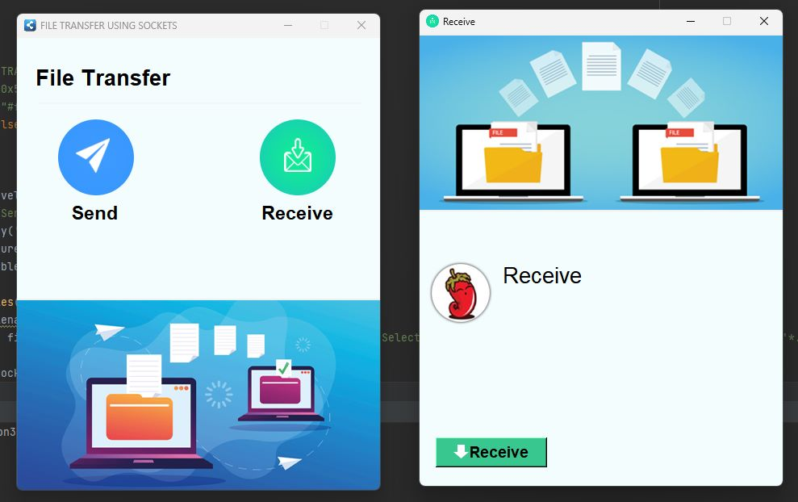

**VII. CONCLUSION**

This project has followed the all necessary steps to create a working file sharing app using python, from inception of the idea through to implementation.

**Recommendations**

There are a number of additions to the application that, despite being unnecessary in light of the previously outlined requirements, would provide the user with more functionality and increase the application's depth. Some of these are modifications to existing code to improve functionality, while others are simply the addition of new components.

Virus scanning of uploaded files would be a useful addition. Because so many files from various users would be uploaded, scanning them would provide security for all users as well as the application by preventing viruses from being shared or stored on the server.

A final thought is to provide file searching and filtering. As users begin to own and gain access to multiple boxes, it is entirely possible that they will lose track of where a specific file is, or that they will want to see a list of all files of a specific file type that they have access to. They would be able to access this information by providing some form of searching and filtering.

Of course, these are just a few extension ideas; there are many more ways to broaden the application and provide more functionality, depending on what is desired.

**REFERENCES:**

<http://www.ijcse.net/docs/IJCSE13-02-05-055.pdf>

<https://www.folkstalk.com/tech/how-to-send-file-using-socket-in-python-with-code-examples/>

<https://www.geeksforgeeks.org/file-sharing-app-using-python/>

<https://www.freecodecamp.org/news/simplehttpserver-explained-how-to-send-files-using-python/>

<https://idiotdeveloper.com/file-transfer-using-tcp-socket-in-python3/>

<https://www.thepythoncode.com/article/send-receive-files-using-sockets-python>

<https://linuxhint.com/python_socket_file_transfer_send/>

**Appendix A – Source Code:**

*from tkinter import \**

*import socket*

*from tkinter import filedialog*

*import pathlib*

*import os*

*root = Tk()*

*root. title("FILE TRANSFER USING SOCKETS")*

*root. geometry("450x560+500+200")*

*root.configure(bg="#f4fdfe")*

*root. resizable(False, False)*

*def Send():*

*window = Toplevel(root)*

*window.title("Send",)*

*window.geometry('450x560+500+200')*

*window. configure(bg="#f4fdfe")*

*window. resizable(False, False)*

*def select_files():*

*global filename*

*global text*

*filename = filedialog.askopenfilename(initialdir=os.getcwd(), title='Select File', filetypes=(('Text file', '*.txt'),('all files', '*.*')))*

*file_extension = pathlib.Path(filename).suffix*

*text = 'received' + file_extension*

*def sender():*

*client = socket.socket(socket.AF_INET, socket.SOCK_STREAM)*

*client.connect(("localhost", 9999))*

*file = open(filename, "rb")*

*file_size = os.path.getsize(filename)*

*client.send(text.encode())*

*client.send(str(file_size).encode())*

*data = file.read()*

*client.sendall(data)*

*client.send(b"<END>")*

*# icon*

*image_icon1 = PhotoImage(file="Image/send.png")*

*window.iconphoto(False, image_icon1)*

*Sbackground = PhotoImage(file="Image/sender.png")*

*Label(window, image=Sbackground).place(x=-2, y=0)*

*Mbackground = PhotoImage(file="Image/id.png")*

*Label(window, image=Mbackground, bg="#f4fdfe").place(x=100, y=260)*

*host = socket.gethostname()*

*Label(window, text=f'ID:{host}', bg='white',fg='black').place(x=140, y=290)*

*Button(window, text="+ Select File", width=10, height=1, font='arial 14 bold',bg="#fff", fg="#000", command=select_files).place(x=160, y=150)*

*Button(window, text="Send", width=8, height=1, font='arial 14 bold',bg="#fff", fg="#000",command=sender).place(x=300, y=150)*

*window.mainloop()*

*def Receive():*

*main = Toplevel(root)*

*main.title("Receive",)*

*main.geometry('450x560+500+200')*

*main.configure(bg="#f4fdfe")*

*main.resizable(False, False)*

*def receiver():*

*server = socket.socket(socket.AF_INET, socket.SOCK_STREAM)*

*server.bind(("localhost", 9999))*

*server.listen()*

*client, addr = server.accept()*

*file_name = client.recv(1024).decode()*

*# print(file_name)*

*file_size = client.recv(1024).decode()*

*# print(file_size)*

*file = open(file_name, "wb")*

*file_bytes = b""*

*done = False*

*while not done:*

*data = client.recv(1024)*

*if file_bytes[-5:] == b"<END>":*

*done = True*

*else:*

*file_bytes += data*

*# icon*

*image_icon1 = PhotoImage(file="Image/receive.png")*

*main.iconphoto(False,image_icon1)*

*Hbackground = PhotoImage(file="Image/receiver.png")*

*Label(main,image=Hbackground).place(x=-2, y=0)*

*logo = PhotoImage(file="Image/profile.png")*

*Label(main,image=logo,bg="#f4fdfe").place(x=10,y=280)*

*Label(main,text="Receive",font=('arial',20),bg="#f4fdfe").place(x=100,y=280)*

*#Label(main,text="Input sender id",font=('arial',10),bg="#f4fdfe").place(x=20,y=340)*

*#SenderId=Entry(main,width=25,fg='black',border=2,bg='white',font=('arial',15))*

*#SenderId.place(x=20,y=370)*

*#SenderId.focus()*

*#Label(main,text="Filename for the incoming file: ",font=('arial',10),bg="#f4fdfe").place(x=20,y=340)*

*#incoming_file=Entry(main,width=25,fg='black',border=2,bg='white',font=('arial',15))*

*#incoming_file.place(x=20,y=450)*

*imageicon=PhotoImage(file="Image/arrow.png")*

*r=Button(main,text="Receive",compound=LEFT,image=imageicon,width=130,bg="#39c790",font='arial 14 bold',command=receiver)*

*r.place(x=20,y=500)*

*main.mainloop()*

*# icon*

*image_icon = PhotoImage(file="Image/icon.png")*

*root.iconphoto(False, image_icon)*

*Label(root, text="File Transfer", font=('Acumin Variable Concept', 20, 'bold'), bg="#f4fdfe").place(x=20, y=31)*

*Frame(root, width=400, height=2, bg="#f3f5f6").place(x=25, y=80)*

*send_image = PhotoImage(file="Image/send.png")*

*send = Button(root, image=send_image, bg="#f4fdfe", bd=0, command=Send)*

*send.place(x=50, y=100)*

*receive_image = PhotoImage(file="Image/receive.png")*

*receive = Button(root, image=receive_image,bg="#f4fdfe", bd=0, command=Receive)*

*receive.place(x=300, y=100)*

*# label*

*Label(root, text="Send", font=('Acumin Variable Concept',17, 'bold'), bg="#f4fdfe") .place(x=65, y=200)*

*Label(root, text="Receive", font=('Acumin Variable Concept',17, 'bold'), bg="#f4fdfe") .place(x=300, y=200)*

*background = PhotoImage(file="Image/background.png")*

*Label(root, image=background).place(x=-2, y=323)*

*root. mainloop()*

**Appendix B – GITHUB PROFILE AND SOUCRE CODE**

<https://github.com/RA2112704010015>

<https://github.com/RA2112704010015/OS_MINI_PROJECT>